**A Project Report**

**on**

**FACE DETECTION IN A VIDEO USING BIG DATA TOOLS AND COMPUTER VISION TECHNIQUES**

Submitted for partial fulfillment of the award of

**BACHELOR OF TECHNOLOGY**

in

**Computer Science and Engineering**

by

**N. SUNEETHA - 20BQ1A05H0**

**P. V. L GAYATHRI - 20BQ1A05H2**

**N. KOTESWARA RAO - 20BQ1A05F9**

**SK. KAHAR MOULA - 21BQ5A0520**

**Under the Guidance of**

**Mrs. G. Rama Devi**

**Assistant Professor**



**(Autonomous)**

**VASIREDDY VENKATADRI INSTITUTE OF TECHNOLOGY**

**An Autonomous Institute**

**Approved by AICTE, Permanently Affiliated to JNTU, Kakinada**

**Accredited by NAAC with ‘A’ Grade - ISO 9001:2008 Certified**

**Nambur (V), Peda Kakani (M), Guntur Dt. - 522508**

**April, 2024.**



**CERTIFICATE**

This is to certify that the project report titled “**FACE DETECTION IN VIDEO USING BIG DATA TOOLS AND COMPUTER VISION TECHNIQUES**” is being submitted by **Ms. N. Suneetha, Ms. P. V. L Gayathri, Mr. N. KoteswaraRao, Mr. Sk. Kahar Moula** bearing Regd No’s **20BQ1A05H0, 20BQ1A05H2, 20BQ1A05F9, 21BQ5A0520** respectively in IV B.Tech II semester *Computer* *Science & Engineering* is a record bonafide work carried out by them. The results embodied in this report have not been submitted to any other University for the award of any degree.

**Project Guide Head of Department**

(Mrs. G. Rama Devi, Assistant Professor) (Dr. V. Ramachandran, Professor )

**Submitted for Viva-voce held on**

**___________________________________________________**

**Internal Examiner External Examiner**

**DECLARATION FORMAT**

We NEERUMALLA SUNEETHA, PABBISETTY VENKATA LAKSHMI GAYATHRI, NADIKOTI KOTESWARA RAO, SHAIK KAHAR MOULAhereby declare that the Project Report entitled “FACE DETECTION VIDEO USING BIG DATA TOOLS AND COMPUTER VISION TECHNIQUES” done by us under the guidance of Mrs. G. RAMA DEVI at Vasireddy Venkatadri Institute of Technology is submitted in partial fulfillment of the requirements for the award of degree in Computer Science and Engineering

DATE :

PLACE:

SIGNATURE OF THE CANDIDATE(s)

1. N. Suneetha - 20BQ1A05H0

2. P. V. L Gayathri -20BQ1A05H2

3. N. Koteswara Rao - 20BQ1A05F9

4. Sk. Kahar Moula - 21BQ5A0520

.

**ACKNOWLEDGEMENT**

We take this opportunity to express my deepest gratitude and appreciation to all those people who made this project work easier with words of encouragement, motivation, discipline, and faith by offering different places to look to expand our ideas and helped us towards the successful completion of this project work.

First and foremost, we express our deep gratitude to **Mr. Vasireddy Vidya Sagar**, Chairman, Vasireddy Venkatadri Institute of Technology for providing necessary facilities throughout the B Tech program.

We express our sincere thanks to **Dr. Y. Mallikarjuna Reddy**, Principal, Vasireddy Venkatadri Institute of Technology for his constant support and cooperation throughout the B. Tech program.

We express our sincere gratitude to **Dr. V. Ramachandran**, Professor & HOD, Computer Science & Engineering, Vasireddy Venkatadri Institute of Technology for his constant encouragement, motivation and faith in offering different places to look to expand our ideas.

We would like to express our sincere gratefulness to our Guide, **Mrs. G. Rama Devi** Assistant Professor, CSE for his insightful advice, motivating suggestions, invaluable guidance, help and support in the successful completion of this project.

We would like to express our sincere heartfelt thanks to our Project Coordinator **Dr. N. Sri Hari**, Associate Professor, CSE for his valuable advices, motivating suggestions, moral support, help and coordination among us in successful completion of this project. We would like to take this opportunity to express our thanks to the Teaching and Non-Teaching Staff in the Department of Computer Science & Engineering, VVIT for their invaluable help and support.

**INDEX**

**CH NO**  **TITLE PAGE NO**

Content i-ii

List of Figures iii

List Of Tables iv

Abstract v

1. Introduction 1-4

* 1. Overview 1-2
  2. Motivation 2-3
  3. Applications 3-4

2. Literature Survey 5-7

3. Aim and scope 8-12

3.1 Existing System 8-10

3.2 Proposed System 10-12

4. Concept and methods 13-28

4.1 Problem Description 13

4.2 Proposed Solution 13-24

4.2.1 Dataset 13-14

4.2.2 Data preparation 14-15

4.2.3 Data Preprocessing 15-16

4.2.4 Data Augmentation 16-17

4.2.5 Models Architectures 17-24

4.3 System Analysis 24-28

4.3.1 Requirement Specification 24-25

4.3.2 Functional Requirements 25-26

4.3.3 Non-Functional Requirements 26

4.4 Block Diagrams 26-28

4.4.1 Flow Chart 26-27

4.4.2 Use Case Diagram 28

5. Implementation 29-53

5.1 Tools Used 29-47

5.2 Code 47-50

5.3 Performance Metric 50-53

6. Results and Screenshots 54-56

7. Conclusion and discussion 57-58

REFERENCES 59-60

APPENDIX

Journal Certificates

Published Article in the journal

**LIST OF FIGURES**

|  |  |  |
| --- | --- | --- |
| **S. NO** | **FIGURE NAME** | **PAGE NO** |
| 1.1 | Sample Face Detection Image | 1 |
| 4.1 | Dataset Images | 14 |
| 4.2 | Yolov8 Architecture | 20 |
| 4.3 | Deep Face Architecture | 22 |
| 4.4 | Apache Spark Architecture | 24 |
| 4.5 | Flow chart Diagram of Face Detection in Video | 27 |
| 4.6 | Use Case Diagram of Face Detection in Video | 28 |
| 6.1 | Sample Input Image | 54 |
| 6.2 | Output screenshot from output video | 56 |

**LIST OF TABLES**

|  |  |  |
| --- | --- | --- |
| **S.NO** | **TABLE NAME** | **PAGE NO** |
| 4.1 | Data Preprocessing | 17 |

**ABSTRACT**

Face detection within video content has long been challenged by precision limitations. However, advancements in technology, particularly the utilization of big data techniques, offer promising solutions to enhance both speed and efficiency in this task. By leveraging Apache Spark, a distributed computing framework capable of running across multiple nodes simultaneously, the conversion of individual video frames into an analyzable format becomes more efficient. The integration of the YOLO Face Detection model, based on deep learning principles, further enhances the accuracy of face detection within each frame. Additionally, Deep Face, a powerful tool for facial recognition, is employed to pinpoint target faces and extract instances across multiple frames. This integrated approach not only addresses the precision limitations traditionally associated with face detection but also opens up possibilities for extensive monitoring and analysis within video content.

**CHAPTER 1**

**INTRODUCTION**

**1.1 Overview**

The application of face detection in video, leveraging big data tools and computer vision techniques, is a fascinating intersection of intensive handling of data and advanced image analysis. Face detection, a crucial task in computer vision, involves the identification and localization of human faces in still or moving images or video frames. This process plays a vital role in various applications, such as security monitoring, emotion analysis, and facial recognition.

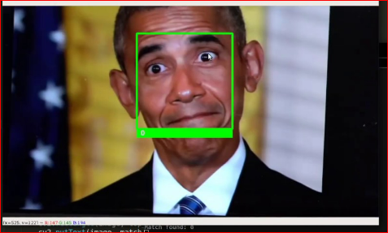

Fig1.1 Sample Face Detection Image

To achieve face detection in videos, algorithms analyses the visual elements of an image or video. Given the considerable volume of data involved in video streams, using big data solutions becomes imperative. Apache Spark, a notable example, proves invaluable due to is scalability, fault tolerance, and distributed processing capabilities. Furthermore, the efficiency of face detection algorithms is critical in real-world scenarios. They must handle dynamic changes in lighting conditions, varying facial expressions, and diverse backgrounds. Robust algorithms contribute to the accuracy and reliability of applications relying on face detection.

OpenCV, an abbreviation for the Computer Vision Open-Source Library, stands as an open-source software library for computer vision and machine learning tasks. It was initially developed by Intel in 1999 and has since become one of the most widely used libraries for real-time computer vision applications. Here's a breakdown of its key features and capabilities.

OpenCV provides a vast array of tools and algorithms for image processing tasks such as filtering, edge detection, morphological operations, and color space manipulation. As face detection applications continue to expand, the integration of real-time processing becomes crucial. Real-time face detection is essential in scenarios such as surveillance, where quick and accurate identification is paramount. This necessitates not only efficient algorithms but also the utilization of parallel processing and optimized hardware for rapid decision making. Moreover, privacy concerns have become increasingly relevant in the deployment of face detection systems.

**1.2 Motivation**

The motivation behind this project stems from the increasing demand for robust and efficient solutions in face detection and verification, particularly in the realm of video processing. Traditional methods often struggle to keep pace with the growing complexity and volume of video data, necessitating the exploration of advanced techniques such as deep learning and parallel processing.

*Enhanced Security Measures:* With the proliferation of surveillance systems and the need for secure access control, there is a heightened requirement for accurate face detection and verification systems. By leveraging deep learning models like YOLOv8 and Deep Face, coupled with parallel processing capabilities of Apache Spark, the proposed system aims to significantly enhance security measures by efficiently identifying and verifying individuals within video streams.

*Improved Accuracy and Efficiency:* Deep learning techniques have shown remarkable performance in various computer vision tasks, including face detection and verification. By utilizing models like YOLOv8 and Deep Face, which are renowned for their accuracy, the project aims to achieve higher detection rates and reduced false positives. Moreover, by harnessing the parallel processing power of Apache Spark, the system endeavors to enhance efficiency by distributing computational tasks across multiple nodes, thereby accelerating the processing of video frames.

*Adaptability to Dynamic Environments:* In dynamic environments where lighting conditions, camera angles, and facial expressions vary, traditional methods often falter. Deep learning models exhibit greater adaptability to such variations due to their ability to learn intricate patterns and features from large datasets. By integrating advanced deep learning techniques, the proposed system aims to deliver robust performance across diverse environments, ensuring reliable face detection and verification in real-world scenarios.

*Scalability and Real-Time Processing:* As the volume of video data continues to surge, scalability becomes a critical factor in designing effective face detection and verification systems.

By leveraging Apache Spark for parallel processing, the proposed system offers scalability to handle large-scale video streams efficiently. Furthermore, the parallel processing approach enables real-time or near-real-time processing of video frames, catering to applications where timely responses are imperative, such as security monitoring and surveillance.

*Technological Advancements:* With advancements in deep learning models and frameworks, coupled with the parallel processing capabilities of distributed computing platforms like Apache Spark, there exists a unique opportunity to develop sophisticated solutions for facial analysis tasks. By capitalizing on these technological advancements, the project aims to push the boundaries of face detection and verification performance, ultimately contributing to the advancement of computer vision research and applications.

In summary, the motivation behind this project lies in addressing the pressing need for accurate, efficient, and scalable solutions in face detection and verification, leveraging state-of-the-art deep learning techniques and parallel processing capabilities to enhance security, accuracy, and adaptability in video-based applications.

**1.3 Applications**

Face detection in video has numerous applications across various industries and domains. Some of the key applications include:

***Security and Surveillance:*** Face detection is widely used in security systems for identifying individuals in real-time. It helps in monitoring crowded areas, airports, public transportation, and other sensitive locations for security purposes. It can also be integrated with access control systems to grant or deny entry based on recognized faces.

***Automated Attendance Systems:*** In educational institutions and workplaces, face detection in videos can automate attendance marking. By analyzing video feeds, attendance can be recorded accurately without manual intervention, saving time and reducing errors.

***Marketing and Advertising:*** Face detection in video enables marketers to gather data on viewer demographics, such as age, gender, and emotional responses to advertisements. This data can be used to tailor marketing campaigns more effectively and personalize content to target audiences.

***Customer Insights:*** In retail environments, face detection can be used to analyze customer behavior, such as dwell time in front of products and overall foot traffic patterns. This information helps retailers optimize store layouts, product placements, and marketing strategies.

***Emotion Analysis and User Experience:*** Face detection can be used to gauge emotional responses of users interacting with software applications or digital content. This information is valuable for improving user experience in areas such as gaming, virtual reality, and customer service interactions.

***Healthcare:***In healthcare settings, face detection in video can assist in patient monitoring and analysis. For example, it can be used to detect signs of pain, distress, or fatigue in patients during consultations or in hospital environments. It can also aid in identifying individuals for medical records and patient tracking.

***Automotive Safety:*** In advanced driver-assistance systems (ADAS) and autonomous vehicles, face detection is used to monitor driver attentiveness and detect signs of drowsiness or distraction. This helps enhance safety by alerting drivers or triggering automated interventions when necessary.

***Entertainment and Content Creation:*** Face detection technology is employed in various entertainment applications, including virtual try-on experiences for cosmetics and fashion, augmented reality filters in social media platforms, and special effects in movies and video games.

***Law Enforcement and Forensics:*** Face detection assists law enforcement agencies in identifying suspects from surveillance footage and tracking their movements across different locations. It also plays a crucial role in forensic investigations by matching faces to criminal databases and reconstructing events.

***Accessibility:*** Face detection technology can improve accessibility features for individuals with disabilities. For instance, it can be used to enable hands-free interaction with devices and software applications, allowing users to control interfaces through facial gestures and expressions.

Overall, the applications of face detection in video are diverse and continue to expand as the technology advances, offering innovative solutions across various sectors.

**CHAPTER-2**

**LITERATURE SURVEY**

Face detection in real-world scenarios poses challenges due to variations in expressions, lighting, and occlusions. Deep learning techniques have shown remarkable success in addressing these challenges by leveraging complex strategies. The proposed deep cascaded multi-task framework exploits correlations between tasks, enhancing performance in face detection and landmark localization. Further improvements and applications of the proposed method are envisaged, leveraging the insights gained from experimentation and analysis[1]. [2] This paper provides an extensive overview of face detection methods, categorizing them into feature-based and image-based approaches, with a focus on the burgeoning role of neural networks (NNs). It highlights the historical evolution of face detection algorithms and their recent advancements propelled by computational resources. The comparative evaluation among different algorithms elucidates their strengths and limitations, shedding light on their applicability in diverse scenarios. Notably, NN models emerge as high-performing algorithms in face detection, leveraging hardware developments to tackle challenges like occlusion and complex backgrounds. The survey extends beyond face detection, exploring the extensive utilization of these algorithms in fault diagnosis, EEG data analysis, and various pattern recognition tasks. The research underscores the imperative of advancing face detection technology to mitigate false positives and unlock its full potential in critical domains.

The study presents a novel approach to physical security using facial recognition technology, integrating Haar Cascade for face detection and LBPH for face recognition. The proposed security system prototype utilizes a microcomputer, Raspberry Pi 4, as the central processing unit to analyze camera feed and control access to the secured area. Overall, the proposed security system offers a promising solution for industries seeking enhanced access control and surveillance capabilities, leveraging facial recognition technology for improved security protocols and incident response mechanisms[3]. [4] The proposed correlation-based approach utilizes response maps from CNN models to improve face detection in video sequences, focusing on aligning face features more accurately in the embedding space. Leveraging automatic neuron selection and response map generation techniques, the framework aims to identify optimal face locations for more consistent and interpretable results. Overall, the proposed correlation-based approach offers a novel and effective solution for enhancing face recognition performance in video sequences, with potential applications in various domains requiring robust and accurate facial recognition capabilities.

Face recognition technology, with its capability to capture and match facial features, has witnessed significant advancements, driven by the robustness of deep learning models and its widespread application across various sectors. The proposed AB-FR model integrates an attention based convolutional neural network (CNN) to enhance feature extraction from facial images, thereby improving recognition performance and robustness[5]. By incorporating bidirectional long short-term memory (BiLSTM), the model captures temporal and geometric features across different images of the same individual, addressing the limitations of traditional deep learning-based methods in considering timing characteristics. The utilization of cross-entropy loss function facilitates efficient model optimization and classification, resulting in improved accuracy and training effectiveness. [6] The integration of face mesh technology with deep neural networks represents a promising approach for robust face detection and recognition, offering versatility across varying conditions such as illumination changes and non-frontal poses. Leveraging the Labeled Wild Face (LWF) dataset and real-time image captures, the proposed model demonstrates significant advancements in accurately identifying individuals, with a commendable accuracy rate of 94.23% achieved for face recognition tasks. This research contributes to the evolving landscape of computer vision and deep learning, providing practical solutions for applications ranging from access control in secure areas to database-driven identification systems, thereby addressing key challenges in face detection and recognition.

This paper offers a comprehensive overview of existing face recognition methods and the factors influencing facial recognition accuracy, addressing the heightened demand for biometric security systems in safeguarding against fraud and theft. It delves into the impact of factors such as aging, pose variation, partial occlusion, illumination, and facial expressions on recognition accuracy, while also exploring techniques aimed at mitigating these effects[7]. [8] The F-DR Net represents a pioneering approach in the realm of face multi-task analysis, offering a unified solution for both face detection and recognition within a single network architecture, addressing the challenges posed by these tasks. Extensively evaluated on benchmark datasets such as Labeled Faces in the Wild (LFW) and Face Detection Datasets and Benchmark (FDDB), the F-DR Net demonstrates superior performance in terms of detection and recognition accuracy while maintaining faster processing speeds compared to existing methods, underscoring its efficacy and practical utility in real- world scenarios. [9] This study presents a new face recognition attendance system leveraging real-time video processing, showcasing its efficacy in enhancing attendance monitoring in educational settings and potentially boosting student engagement and institutional efficiency.

This paper presents a thorough review of current research trends in video-based face recognition and retrieval, highlighting the shift from traditional still-image approaches to leveraging the rich

and redundant information provided by video data for more accurate and robust recognition in unconstrained environments[10] .This paper presents an experimental surveillance system that addresses the challenges of robust face recognition in real-time applications, emphasizing the utilization of Viola-Jones face detection coupled with shape-based feature extraction to ensure resilience to variations in illumination, scale, pose, and expression, thus enhancing both detection and recognition accuracy[11]. [12] This paper presents a robust approach for face detection in multiple views and landmark localization using Multi-task Cascaded Convolutional Networks (MTCNN), demonstrating high accuracy in both frontal and non-frontal face detection scenarios. The proposed method enhances detection accuracy, particularly for large-angle faces, offering a comprehensive solution for complex environments.

**CHAPTER 3**

**AIM AND SCOPE**

The aim of this project is to improve the precision and efficiency of face detection within video content by leveraging big data techniques. Specifically, the project seeks to employ Apache Spark for parallel processing across multiple nodes to convert individual video frames into an analyzable format. Additionally, the project aims to utilize the YOLO Face Detection model for robust face detection within each frame, followed by Deep Face for precise identification and tracking of target faces across multiple frames.

**3.1 Existing System**

Face detection in real-world scenarios presents challenges due to variations in expressions, lighting, and occlusions. Deep learning techniques have emerged as effective tools in addressing these challenges. Various methodologies and frameworks focus on improving face detection accuracy and efficiency.

Deep learning models, such as the deep cascaded multi-task framework, exploit correlations between tasks to enhance face detection and landmark localization. These approaches leverage complex strategies to improve detection accuracy across diverse scenarios. Studies propose correlation-based approaches that utilize response maps from CNN models to improve face detection in video sequences. By aligning face features more accurately, these methods aim to provide consistent and interpretable results.

Researchers leverage specialized datasets to train and evaluate face detection models. The integration of face mesh technology with deep neural networks demonstrates advancements in accurately identifying faces across varying conditions.

The application of these advancements extends to practical security and surveillance systems. Prototypes utilizing technologies like Haar Cascade for face detection, integrated with microcomputers such as Raspberry Pi, offer promising solutions for enhancing access control and surveillance capabilities in various industries.

The existing literature highlights the use of deep learning techniques and advanced methodologies to enhance face detection precision. By addressing challenges such as variations in expressions and lighting conditions, these approaches offer improved accuracy and efficiency in detecting faces within video content.

The landscape of face detection and recognition systems is evolving rapidly, driven by advancements in deep learning techniques and their applications across various domains. Traditionally, face detection in real-world scenarios has been challenged by factors such as variations in expressions, lighting conditions, and occlusions. However, deep learning techniques have demonstrated remarkable success in addressing these challenges, leveraging complex strategies to achieve higher precision and efficiency.

One notable approach proposed in recent research is the deep cascaded multi-task framework, which exploits correlations between tasks to enhance performance in both face detection and landmark localization. This framework capitalizes on deep learning's ability to learn intricate patterns and relationships within data, resulting in improved accuracy and robustness in detecting faces across different conditions.

Additionally, advancements in face recognition technology have been propelled by the robustness of deep learning models, enabling significant improvements in recognition accuracy. The proposed AB-FR model, for instance, integrates convolutional neural networks (CNNs) with attention mechanisms to enhance feature extraction from facial images. By considering temporal and geometric features across different images of the same individual, this model addresses the limitations of traditional deep learning-based methods, resulting in enhanced recognition performance and robustness.

Furthermore, the integration of face mesh technology with deep neural networks presents a promising approach for robust face detection and recognition, offering versatility across varying conditions such as illumination changes and non-frontal poses. Leveraging datasets like the Labeled Wild Face (LWF), researchers have achieved commendable accuracy rates in face recognition tasks, showcasing practical solutions for access control and identification systems.

Moreover, comprehensive surveys and studies have provided insights into the historical evolution of face detection and recognition algorithms, highlighting the increasing role of neural networks in driving advancements in this field. The comparative evaluations among different algorithms have shed light on their strengths and limitations, emphasizing the need for continuous improvement to mitigate false positives and unlock the full potential of face detection technology in critical domains.

In summary, the existing systems and methodologies discussed in recent research underscore the ongoing efforts to enhance the accuracy, efficiency, and applicability of face detection and recognition systems.

Leveraging deep learning techniques and insights gained from experimentation and analysis, researchers and developers continue to push the boundaries of what is achievable in this field, paving the way for innovative solutions with diverse applications in security, surveillance, education, and beyond.

**3.2 Proposed System**

The proposed system aims to utilize advanced deep learning techniques for accurate face detection and verification in videos. It combines the YOLOv8 model for face detection and the Deep Face model for face verification. Additionally, Apache Spark is employed for parallel processing of video frames to enhance speed and efficiency.

The training process involves initializing the YOLOv8 model with pre-trained weights and setting up data loaders to load the training dataset, which comprises face images. The model is then trained on the dataset for multiple epochs to learn features for face detection tasks. Once trained, the model is validated on a separate dataset to evaluate its performance. The validation module is initialized with the trained model and validation dataset. Various metrics, including confusion matrix-based metrics for object detection tasks, are computed to assess the model's performance. The evaluation results are recorded for analysis.

The pretrained Deep Face model is loaded to perform face verification. Detected faces from the video frames are passed as input to the Deep Face model along with the target image for verification. The algorithm extracts features from detected faces and matches them against known identities to verify the presence of the target face in the video frames. The frames containing matched faces from the Deep Face module are combined using the Moviepy module. The matched faces across frames are extracted and compiled into a single video output containing instances of the target image within the video.

Apache Spark is employed for parallel processing of video frames to enhance efficiency. The input image and video are processed, and the frames of the video are distributed to processors via Apache Spark for parallel processing. Apache Spark distributes the frames across multiple nodes for simultaneous processing. This distributed approach enables faster processing of video frames, reducing the overall processing time. After processing, Apache Spark returns the frames that match with the target image, facilitating efficient face detection and verification in the video content. The proposed system leverages advanced deep learning techniques to achieve accurate face detection and verification in videos. It integrates the YOLOv8 model for face detection and the Deep Face model for face verification, ensuring comprehensive coverage of facial analysis tasks. Additionally, Apache Spark is harnessed for parallel processing of video frames, enhancing speed and efficiency by distributing computational tasks across multiple nodes.

In the training phase, the YOLOv8 model is initialized with pre-trained weights and trained on a dataset consisting of face images. Data loaders are set up to facilitate the loading of the training dataset, enabling the model to learn features relevant to face detection. Subsequently, the trained model undergoes validation on a separate dataset to evaluate its performance, with metrics like confusion matrix-based metrics employed to assess its accuracy and effectiveness.

Once trained, the pretrained Deep Face model is utilized for face verification. Detected faces from video frames are passed as input to the Deep Face model alongside the target image for verification. Features are extracted from detected faces and matched against known identities, enabling the verification of the target face's presence within the video frames. Matched faces across frames are then consolidated into a single video output using the Moviepy module, providing a visual representation of instances where the target image is detected.

Apache Spark plays a pivotal role in enhancing processing efficiency by enabling parallel processing of video frames. Through Apache Spark's distributed computing capabilities, frames of the video are distributed across multiple nodes for simultaneous processing, significantly reducing processing time. This distributed approach not only enhances speed but also ensures efficient utilization of computational resources. Comprehensive workflow utilizing Google Colab for various tasks, including downloading datasets, training machine learning models, performing predictions, and processing video data.

***Setting up the Environment:*** The initial part of the code defines the current location in the Google Colab home directory and prints it. Then, it installs the Ultralytics library for YOLO, a popular object detection framework.

***Downloading and Preparing the Dataset:*** The code navigates to the home directory and installs the Roboflow library to download datasets. It specifies the project and version from which the dataset should be downloaded and sets up the dataset for training with YOLO.

***Training the Dataset:*** After downloading the dataset, the code trains the YOLO model using the specified parameters, such as the number of epochs and image size. This step is crucial for creating a model capable of detecting faces in images or videos.

***Validating the Dataset:*** Following the training, the code validates the dataset by running the trained model on a validation set. This step ensures that the model performs well and generalizes effectively to unseen data.

***Performing Predictions:*** Once the model is trained and validated, the code demonstrates how to use the trained model for making predictions. It specifies a video file as the input source and detects faces using the trained YOLO model, saving the results to a text file.

***Installing Additional Libraries:*** The code installs additional libraries required for face verification and video processing, such as DeepFace for face verification and MoviePy for video editing.

***Setting Environment Variables:*** Environment variables for Java and Spark are set to configure the Spark application. This step is essential for running Spark jobs within the Colab environment.

***Creating Spark Application:*** The code initializes a Spark Context and Spark Session, enabling the execution of distributed computations using Apache Spark.

***Face Verification:*** Using the DeepFace library, the code performs face verification by comparing a target image with frames extracted from a video. This step helps in identifying and verifying faces in the video data.

***Creating a Video:*** Finally, the code combines all the frames containing detected faces with the target image to create a video. This process involves assembling individual image frames into a sequence and saving it as a video file.

Overall, the combination of YOLOv8 for face detection, Deep Face for face verification, and Apache Spark for parallel processing forms a robust system for accurate and efficient facial analysis in videos. By leveraging the strengths of each component, the system is capable of handling large-scale video datasets while delivering high levels of accuracy and performance in face detection and verification tasks.

**CHAPTER 4**

**CONCEPTS AND METHODS**

**4.1 Problem Description**

The problem addressed in this project focuses on automating face detection and verification within video content using advanced deep learning techniques. Traditional face detection methods often encounter challenges in accurately identifying faces in video streams, particularly in real-time scenarios where precision and efficiency are crucial. Additionally, manual verification of detected faces can be time-consuming and subjective, requiring automated systems to improve accuracy and efficiency.

To tackle these challenges, this project leverages state-of-the-art deep learning models, specifically YOLOv8 for face detection and Deep Face for face verification. YOLOv8 is a robust and efficient model known for its real-time capabilities and high accuracy in detecting objects, including faces, within images and videos. Deep Face, on the other hand, specializes in facial recognition tasks, allowing for the verification of detected faces against known identities.

Furthermore, to enhance processing speed and efficiency, Apache Spark is utilized for parallel processing of video frames. Apache Spark's distributed computing framework enables simultaneous processing of multiple video frames across multiple nodes, significantly reducing processing time and enabling real-time face detection and verification. The project aims to overcome the limitations of traditional face detection methods by leveraging advanced deep learning techniques and parallel processing capabilities.

**4.2 Proposed Solution**

**4.2.1 Dataset**

The "face-detection-mik1i" dataset, hosted on Roboflow, emerges as a valuable resource tailored for machine learning tasks, particularly in the domain of face detection. Curated explicitly for this purpose, the dataset contains a diverse array of images showcasing human faces, ready to be detected and localized by machine learning models. With varying resolutions, lighting conditions, backgrounds, and facial orientations, the dataset mirrors real-world scenarios, providing a comprehensive and representative collection for training and evaluation purposes. Each image within the dataset is meticulously annotated with bounding boxes, delineating the precise locations of faces, a fundamental aspect for supervised learning tasks.

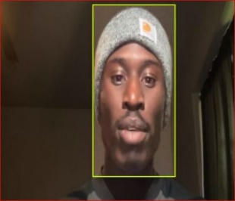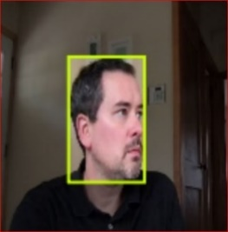

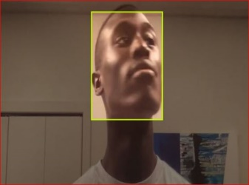

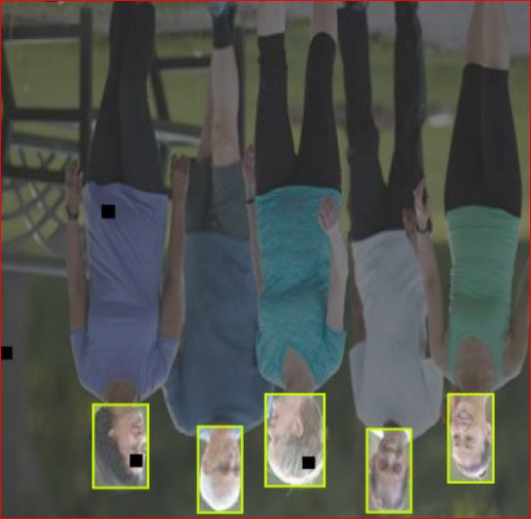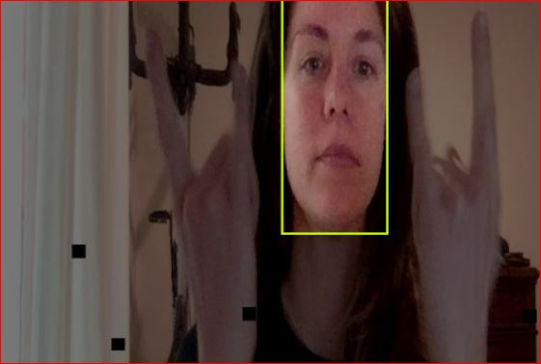

Fig4.1 Dataset Images

**4.2.2 Dataset Preparation**

The dataset preparation involves the organization and partitioning of images containing faces, each annotated with bounding boxes indicating the precise location of the faces. This dataset, obtained from Robo-flow, serves as a foundational resource for training and evaluating face detection models.

The dataset is divided into three subsets: the train set, the validation set, and the test set. The train set comprises 87% of the total images, totaling 2871 images, while the validation set consists of 8%, totaling 267 images. Finally,

the test set constitutes 4% of the dataset, containing 145 images. This division facilitates robust evaluation and validation of face detection algorithms across different stages of development.

Every image within the dataset is annotated with bounding boxes, meticulously indicating the locations of faces present in the image. These annotations are crucial for supervised learning tasks, enabling machine learning models to learn and accurately detect faces within images. By providing annotated bounding boxes, the dataset offers valuable ground truth information necessary for training and evaluating the performance of face detection models.

Overall, the dataset preparation ensures the availability of a well-organized and annotated dataset suitable for training, validating, and testing face detection algorithms. This dataset serves as a foundational resource for researchers, developers, and practitioners seeking to advance the field of computer vision, particularly in the domain of face detection.

**4.2.3 Dataset Preprocessing**

The preprocessing of the dataset involves several essential steps to ensure uniformity, standardization, and suitability for face detection tasks. In this case, the following preprocessing techniques have been applied:

The Auto-Orient operation is applied to adjust the orientation of images automatically. This step ensures that all images are correctly oriented, eliminating any potential inconsistencies or misalignments that may affect the accuracy of face detection algorithms. By aligning the orientation of images, the preprocessing step enhances the reliability and consistency of subsequent processing stages.

The resizing operation involves adjusting the dimensions of images to a standardized size of 640x640 pixels. Resizing images to a consistent resolution is crucial for ensuring uniformity across the dataset. By stretching images to the specified dimensions, variations in image sizes are minimized, facilitating easier processing and analysis. Additionally, resizing images to a larger dimension may help preserve important details and features, enhancing the performance of face detection algorithms.

Overall, the preprocessing of the dataset involves these essential steps to standardize and optimize the images for face detection tasks. By applying Auto-Orient to correct image orientations and resizing images to a consistent resolution of 640x640 pixels, the dataset is prepared in a manner conducive to accurate and efficient face detection algorithm training and evaluation.

**4.2.4 Data Augmentation**

Data augmentation is a crucial preprocessing technique employed to increase the diversity and robustness of a dataset, particularly in computer vision tasks such as face detection. The provided parameters specify various transformations applied to the images to create augmented versions. Here's how each parameter contributes to data augmentation:

***90deg Rotate:*** Images are rotated clockwise, counter-clockwise, or upside down by 90 degrees. This augmentation introduces variations in the orientation of faces, enhancing the model's ability to detect faces regardless of their orientation in the input images.

***Flip:*** Horizontal and vertical flips are applied to images. Flipping horizontally or vertically creates mirrored versions of the original images, introducing variations in facial features' positions and orientations.

***Crop:*** Images are randomly cropped with a minimum zoom of 0% and a maximum zoom of 25%. Cropping focuses on specific regions of the images, simulating different scales and viewpoints, which can help the model generalize better to faces of varying sizes and positions.

***Gray Scale:*** Gray scale transformation is applied to 5% of the images. Converting images to grayscale removes color information, making the model more robust to variations in lighting conditions and color distributions.

***Hue, Saturation, Brightness, and Exposure:*** Random adjustments are made to the hue, saturation, brightness, and exposure levels of images within specified ranges. These adjustments simulate changes in lighting conditions and color tones, improving the model's adaptability to diverse environments.

***Blur:*** Gaussian blur with a maximum kernel size of 1 pixel is applied to images. Blurring introduces smoothness and reduces high-frequency noise, potentially enhancing the model's ability to focus on essential facial features while ignoring irrelevant details.

***Cutout:*** Five rectangular regions, each with a size of 2% of the image's area, are randomly removed from images. This cutout augmentation helps the model learn robust features by forcing it to focus on other parts of the image, thus preventing overfitting and improving generalization.

By applying these data augmentation techniques, the dataset is augmented with a diverse range of variations, such as different orientations, scales, colors, and distortions.

This augmented dataset provides a richer training environment for face detection models, enabling

them to learn more robust and generalizable representations of facial features.

|  |  |
| --- | --- |
| **Parameters** | **Value** |
| 90deg Rotate | Clockwise, Counter-Clockwise, Upside Down |
| Flip | Horizontal, Vertical |
| Crop | 0% Minimum Zoom, 25% Maximum Zoom |
| Gray Scale | Apply to 5% of images |
| Hue | Between -20° and +20° |
| Saturation | Between -10% and +10% |
| Brightness | Between -10% and +10% |
| Exposure | Between -10% and +10% |
| Blur | Up to 1px |
| Cutout | 5boxes with 2% size each |

Table 4.1: Data Preprocessing

**4.2.5 Model Architectures**

**1. YOLOV8 Model**

YOLOv8, or You Only Look Once version 8, is an object detection algorithm that belongs to the YOLO (You Only Look Once) family of models. YOLO models are known for their real-time object detection capabilities, meaning they can quickly and accurately identify objects within an image or a video frame.

***Backbone Network:*** YOLOv8 uses a backbone network, often based on CSPDarknet53, which is an extended version of Darknet, a deep neural network designed for object detection. The backbone extract features from the input image.

***Feature Pyramid Network (FPN):*** YOLOv8 employs a Feature Pyramid Network to capture features at different scales. This helps in detecting objects of varying sizes within an image.

***Detection Head:*** The detection head in YOLOv8 is tasked with predicting both bounding boxes and the probabilities of various classes. It uses a set of convolutional layers to process the feature maps from the backbone and FPN, producing predictions for each grid cell.

***Anchor Boxes:*** YOLOv8 utilizes anchor boxes to improve bounding box prediction accuracy. These anchor boxes are predefined sizes that help the model better adapt to the scale of different objects in the image.

***Output Format:*** The final output of YOLOv8 is a set of bounding boxes, each associated with a specific class and its confidence score. The bounding boxes are predicted for different grid cells and anchor boxes at multiple scales.

***Training:*** YOLOv8 is trained using a combination of labeled images and their corresponding bounding box annotations. The model is optimized using techniques like stochastic gradient descent with backpropagation.

***Variants:*** YOLOv8 has different variants, including YOLOv8-S, YOLOv8-M, YOLOv8-L, and YOLOv8-X, with varying model sizes and computational demands. Users can choose a variant based on their specific requirements regarding speed and accuracy.

YOLOv8, as a variant within the YOLO (You Only Look Once) family of object detection models, is characterized by its architecture composed of several distinctive layers. At the outset, the Input Layer serves as the entry point, receiving fixed-size input images for processing. These images then undergo feature extraction facilitated by Convolutional Layers, which employ filters of varying sizes and quantities to capture features across different scales within the input data.

Following feature extraction, Downsampling Layers come into play, employing techniques like max-pooling or convolutional strides to reduce the spatial dimensions of the feature maps while enhancing depth. Intermediate Layers further refine feature extraction, utilizing a combination of convolutional operations and activation functions to enhance the network's understanding of the input data.

Upsampling Layers subsequently reverse the downsampling process, restoring spatial dimensions while decreasing depth. Concatenation Layers play a crucial role in merging feature maps from different stages of the network, enabling the model to capture both low-level and high-level features effectively.

The core of the YOLO architecture lies in its Detection Layers, where the model predicts bounding boxes, confidence scores, and class probabilities. These layers typically consist of a series of convolutional operations culminating in a final convolutional layer with a fixed number of filters corresponding to the number of anchor boxes and classes.

In YOLOv8, the Input Layer is where the neural network begins processing the input image data. This layer normalizes the input images and prepares them for further computation. The dimensions of the input images are typically fixed to match the requirements of the network architecture.

As the input images pass through the network, Convolutional Layers play a pivotal role in extracting intricate features. These layers utilize convolutional filters to detect patterns and features within the images. YOLOv8 often employs a stack of convolutional layers with varying filter sizes to capture features at different scales and complexities.

Following the Convolutional Layers, Downsampling Layers are introduced to reduce the spatial dimensions of the feature maps while increasing depth. These layers help in retaining important information while effectively reducing the computational load of subsequent layers.

Intermediate Layers further refine the extracted features, employing additional convolutional operations and activation functions such as ReLU (Rectified Linear Unit) to introduce non-linearity into the network. These layers aid in enhancing the network's ability to discern intricate details and patterns within the input data.

Upsampling Layers come into play to reverse the down sampling process, restoring the spatial dimensions of the feature maps while reducing depth. These layers are crucial for preserving spatial information and facilitating precise localization of objects within the images.

Concatenation Layers merge feature maps from different stages of the network, enabling the model to fuse information from multiple scales and abstraction levels. This integration of features enhances the model's capability to accurately detect objects of varying sizes and complexities.

Detection Layers serve as the crux of the YOLOv8 architecture, responsible for predicting bounding boxes, confidence scores, and class probabilities for detected objects. These layers undergo a series of convolutional operations and are typically followed by post-processing steps to refine the predictions and eliminate redundant detections.

Lastly, the Output Layer synthesizes the predictions generated by the detection layers into a coherent format, providing the final output of the model. This output includes bounding box coordinates, confidence scores indicating the model's certainty about the presence of objects, and class probabilities indicating the likelihood of each detected object belonging to a particular class.

In summary, the YOLOv8 architecture comprises a sophisticated arrangement of layers, each contributing uniquely to the model's ability to perform efficient and accurate object detection tasks.

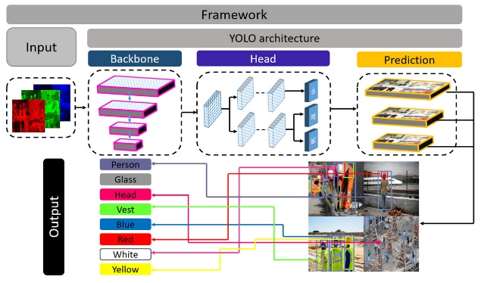

Fig4.2: YOLOv8 Architecture

**2. Deep Face Model**

"Deep Face" refers to a deep learning-based face recognition system developed by Facebook's AI Research (FAIR) lab. It gained significant attention when it was introduced in 2014 due to its high accuracy in identifying faces across large datasets. Here's an overview:

*Architecture:* Deep Face utilizes a deep convolutional neural network (CNN) architecture, which is trained on a massive dataset of labeled face images. The network consists of multiple layers that learn hierarchical representations of facial features, enabling it to recognize faces with high accuracy.

*Face Verification:* Deep Face is primarily designed for face verification tasks, which involve determining whether two face images belong to the same person or not. It accomplishes this by encoding facial images into a compact representation (embedding) in a high-dimensional space, where the similarity between two embeddings can be measured using techniques like cosine similarity or Euclidean distance.

*Training Data:* Deep Face was trained on a large-scale dataset called the "Social Face Classification" dataset, which contains millions of labeled face images belonging to thousands of individuals. This extensive training dataset helped Deep Face learn robust representations of facial features, enabling it to generalize well to unseen faces.

*Performance:* Deep Face achieved state-of-the-art performance on various face recognition benchmarks, surpassing previous methods in terms of accuracy and scalability. In particular, it demonstrated high accuracy even in challenging conditions such as variations in pose, lighting, and facial expression.

Overall, Deep Face represents a significant advancement in the field of face recognition, demonstrating the power of deep learning techniques for accurately identifying and verifying individuals in images. However, it also underscores the importance of addressing privacy and ethical concerns associated with the widespread adoption of facial recognition technology.

For face identification tasks, deep neural network architectures like DeepFace typically incorporate a series of specialized layers designed to extract meaningful features from facial images and generate embeddings that can be used to uniquely identify individuals. At the forefront of these architectures lies the Input Layer, where facial images are fed into the network for processing. These images undergo preprocessing steps to standardize their size, format, and orientation, ensuring consistency across the dataset.

Convolutional Layers form the backbone of the network, responsible for extracting hierarchical features from the input facial images. These layers apply learnable filters to the input data, capturing patterns at varying levels of abstraction, ranging from simple edges and textures to complex facial features like eyes, noses, and mouths. Activation Layers, commonly employing functions like ReLU, introduce non-linearity into the network, enabling it to learn intricate relationships within the facial data.

Pooling Layers, such as max pooling or average pooling, play a crucial role in downsampling the feature maps generated by convolutional layers. By reducing the spatial dimensions of the feature maps while retaining essential spatial information, these layers help mitigate computational complexity and facilitate more efficient processing. Furthermore, normalization techniques like batch normalization may be applied to stabilize and accelerate the training process by ensuring

consistent activations across different layers of the network.

In some architectures, Residual Blocks are incorporated to enable the training of deeper networks by addressing the vanishing gradient problem. These blocks utilize residual connections to bypass certain layers, allowing the network to learn residual mappings rather than directly mapping inputs to outputs.

This architectural design enhances the model's ability to capture fine-grained details and nuances present in facial images, leading to more robust representations.

Fully Connected Layers, also known as dense layers, serve as the interface between the feature representations extracted by the convolutional layers and the final output space. In face identification tasks, these layers typically generate facial embeddings, which are high-dimensional representations of facial features. These embeddings encode the unique characteristics of each individual's face in a compact and discriminative manner, enabling efficient comparison and identification.

The Output Layer of the network produces the final predictions or similarity scores, which quantify the degree of similarity between facial embeddings. Common metrics used for measuring similarity include cosine similarity or Euclidean distance. Additionally, specialized loss functions such as contrastive loss or triplet loss are employed to quantify the discrepancy between predicted and ground truth identities, guiding the network towards more accurate representations.

In summary, deep neural network architectures for face identification tasks comprise a sophisticated arrangement of layers tailored to extract and encode facial features effectively. While the specifics of proprietary models like DeepFace remain undisclosed, the general architecture outlined above encapsulates the key components commonly found in state-of-the-art face recognition systems.

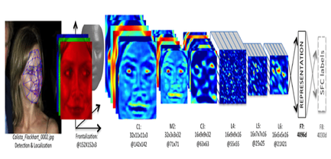

Fig4.3: Deep face Architecture

**3.Apache Spark**

Fast and versatile, Apache Spark is a cluster computing platform made. for distributed data processing. It offers a programming interface with implicit data parallelism and fault tolerance for entire clusters. Spark was created in Scala and is compatible with many programming languages, such as java, Python and R, so a broad spectrum of developers can use it.

There are lot of features in spark. When compared to other conventional data processing technologies, Spark is renowned for its extraordinary speed. By using in-memory processing, it lessens the requirement for a lot of disk input/output. Faster processing speeds are achieved by optimizing job execution through the usage of the Directed Acyclic Graph (DAG) execution.

A high-level API in Java, Scala, Python and R is provided by Spark, which streamlines the development process. Additionally, it offers interactive shell functionality so that code snippets can be examined and tested before being integrated into more complex workflows.

There is high adaptability in Apache Spark. Resilient distributed datasets and lineage information are two ways that spark provides fault tolerance. Spark can recompute an RDD using lineage information in the event that a partition is lost, guaranteeing data integrity and dependability.

Apache Spark's architecture is built to handle large-scale data processing tasks efficiently through distributed computing. At the heart of this architecture lies the Driver Program, which serves as the main control process. The Driver Program splits the user's application into tasks and coordinates their execution across the cluster. It maintains critical information about the application state, including the Directed Acyclic Graph (DAG) of operations and the lineage of Resilient Distributed Datasets (RDDs), which ensures fault tolerance and data recovery in case of failures.

Apache Spark can run on various cluster managers, such as Apache YARN, Apache Mesos, or its standalone cluster manager. These cluster managers allocate resources across applications running on the cluster and oversee their execution. Executors, the worker nodes in the Spark cluster, are responsible for executing tasks. Each executor can handle one or more tasks concurrently and manages data partitions in memory or disk. Executors communicate with the Driver Program and other executors for task coordination and data exchange.

Resilient Distributed Dataset (RDD) serves as the fundamental data abstraction in Apache Spark. RDDs represent distributed collections of immutable objects that are partitioned across the cluster and can be operated on in parallel. Spark transformations, such as map, filter, and reduce, are applied to RDDs to perform data processing tasks. RDD lineage ensures fault tolerance by tracking the sequence of transformations applied to the original data, enabling data recovery in case of failures.

The Directed Acyclic Graph (DAG) scheduler plays a crucial role in optimizing the execution plan of the Spark application. It converts the user's application into a logical execution plan represented as a DAG of stages.

The scheduler identifies opportunities for optimization, such as pipelining and task co-location, to improve performance. Tasks are scheduled for execution by the Task Scheduler, which handles task distribution, fault tolerance, and data locality optimization. Tasks are scheduled to run on nodes where the data they require is already present, reducing data transfer overhead.

Apache Spark provides various storage levels to control how RDDs are stored in memory or on disk. Cached RDDs can be stored in memory across iterations or stages, improving performance by avoiding recomputation. Overall, Apache Spark's architecture is designed for scalability, fault tolerance, and efficient distributed data processing, making it well-suited for handling large-scale datasets and complex data processing workflows effectively.

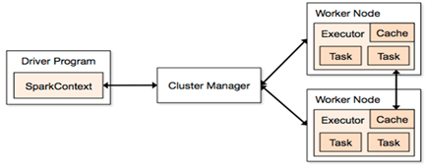

Fig4.4: Apache Spark Architecture

**4.3 System Analysis**

**4.3.1 Requirement Specification**

Requirements analysis, also called requirements engineering, is the process of determining user expectations for a new or modified product. These features, called requirements, must be quantifiable, relevant and detailed. In software engineering, such requirements are often called functional specifications. Requirements analysis is critical to the success or failure of a systems or software project. The requirements should be documented, actionable, measurable, testable, traceable, related to identified business needs or opportunities, and defined to a level of detail sufficient for system design.

**4.3.2 Functional Requirements**

Functional requirements define the internal workings of the software: that is, the technical details, data manipulation and processing and other specific functionality that show how the use cases are to be satisfied. They are supported by non-functional requirements, which impose constraints on the design or implementation.

**Hardware Requirements**

The hardware requirements serve as the basis for the implementation of the system. They are used by software engineers as the starting point for system design. It shows what the system does and not how it should be implemented.

Processor: Intel core i5

Processor speed: 1.30GHZ or above

RAM: 8GB or above

**Software Requirements**

The software requirements document is the software specification of the system. It should include both a definition and a specification of requirements. It is a set of what the system should do rather than how it should do it. It is useful in estimating the cost, planning team activities, performing tasks, and tracking the team's progress throughout the development activity.

Operating system: Windows 11

Programming Language: Python

IDE: Google Colab

Modules:

* OpenCV
* NumPy
* Ultralytics
* Moviepy
* Pyspark
* Roboflow
* DeepFace

**4.3.3 Non -Functional Requirements**

Non-functional requirements are requirements which specify criteria that can be used to judge the operation of a system, rather than specific behaviors. This should be contrasted with functional requirements that specify specific behavior or functions. Typical non- functional requirements often called the utilities of a system. Other terms for non-functional requirements are "constraints", "quality attributes" and "quality of service requirements". Reliability: If any exceptions occur during the execution of the software it should be caught and thereby prevent the system from crashing.

*Scalability:* The system should be developed in such a way that new modules and functionalities can be added, thereby facilitating system evolution.

*Cost:* The cost should be low because a free availability of software package.

**4.4 Block Diagrams**

Block diagrams, flowcharts, and use case diagrams are all tools used in different contexts to represent processes, systems, or interactions.

Block diagrams are a type of diagram that represents a system or process as a series of interconnected blocks, each representing a specific component or function. These blocks are typically geometric shapes, such as rectangles or squares, with labels describing their function or purpose. Arrows or lines connecting the blocks indicate the flow

of information or signals between them. Block diagrams are often used in engineering, electronics, and control systems to illustrate the structure and interactions within a system at a high level. They help visualize the overall architecture and components of a system, making it easier to understand and analyze complex systems.

**Flowcharts**:

Flowcharts are diagrams that depict the flow of control or data within a system or process. They use a variety of symbols and shapes, such as rectangles, diamonds, circles, and arrows, to represent different steps, decisions, inputs, and outputs in a process. Each symbol has a specific meaning, such as a rectangle representing a process step, a diamond representing a decision point, and arrows

indicating the flow of control or data between steps. Flowcharts are widely used in various fields, including software development, business process management, and project management, to document, analyze, and communicate processes and workflows. They help visualize the sequence of steps in a process, identify potential bottlenecks or inefficiencies, and facilitate communication and collaboration among stakeholders.

**Use Case Diagrams**:

Use case diagrams are a type of behavioral diagram in the Unified Modeling Language (UML) that depict the interactions between a system and its users or other systems in terms of use cases and actors. Use cases represent the specific functionalities or features that a system provides to its users, while actors represent the users or external systems interacting with the system. Use case diagrams use oval-shaped symbols to represent use cases, stick figures or other symbols to represent actors, and lines to indicate the relationships or interactions between them. Use case diagrams are commonly used in software development to capture and communicate the functional requirements of a system from the perspective of its users. They help identify the different ways users can interact with the system, clarify the system's scope and boundaries, and serve as a basis for further elaboration and refinement of requirements during the software development process.

**4.4.1 Flow Chart**

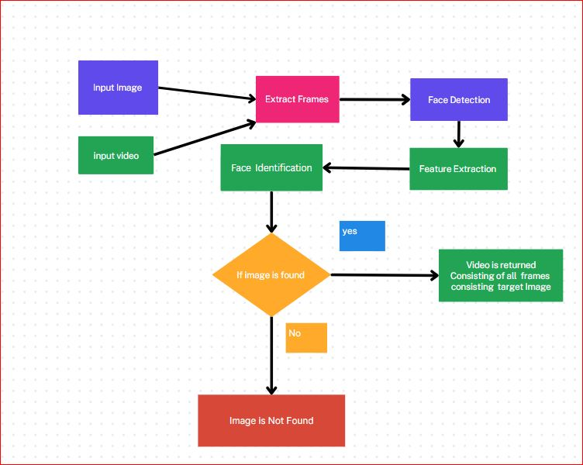

Fig3.5: Flow chart Diagram of Face Detection in Video

**4.4.2 Use Case Diagram**

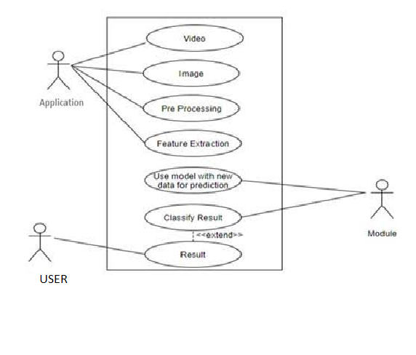

Fig 3.6: Use case Diagram of Face Detection in Video

**CHAPTER 5**

**IMPLEMENTATION**

**5.1 TOOLS USED**

In the implementation of the "Face detection in a video using big data tools and computer vision techniques" system, various tools and technologies are utilized to train. These tools facilitate different aspects of the project, including data preprocessing, model training. Here are the key tools used:

**5.1.1 Python**

Python, a versatile and widely-used programming language, plays a central role in our face detection project. Renowned for its simplicity, readability, and extensive libraries, Python provides a robust foundation for implementing complex computer vision algorithms and techniques. With its intuitive syntax and dynamic typing, Python facilitates rapid development and experimentation, enabling us to iterate quickly on our face detection system.

Python's ecosystem boasts a plethora of libraries and frameworks tailored for various tasks, making it an ideal choice for our project. One of the key libraries we leverage is OpenCV (Open Source Computer Vision Library), which offers a comprehensive suite of tools for image and video processing. Through OpenCV's Python bindings, we gain access to functions for tasks such as face detection, feature extraction, and object tracking, empowering us to build a robust face detection pipeline

Moreover, Python's compatibility with cloud-based platforms like Google Colab enhances our project's scalability and accessibility. By harnessing the computational resources provided by Google Colab, including GPU acceleration, we expedite our model training and experimentation processes. This collaboration between Python and Google Colab enables us to tackle large-scale video datasets and optimize our face detection algorithms efficiently.

Python's versatility extends to its integration with libraries like MoviePy, which facilitates video editing and manipulation. Leveraging MoviePy's capabilities, we can enhance our video analysis by applying transformations, annotations, and overlays to visualize the results of our face detection algorithm dynamically.

This integration enriches our understanding of the face detection process and facilitates the interpretation of our findings.

**Features of Python**:

Python is a versatile and powerful programming language known for its simplicity, readability, and wide range of features. Here are some of the key features that make Python a popular choice among developers:

***Simple and Readable Syntax:*** Python's syntax is designed to be intuitive and readable, making it easy for developers to write clean and maintainable code. Its use of indentation for block delimiters also enforces a consistent coding style.

***Interpreted and Interactive:*** Python is an interpreted language, which means that code can be executed line by line, making it suitable for interactive development and experimentation. This interactive mode, accessed through the Python interpreter or specialized environments like Jupyter notebooks, facilitates rapid prototyping and debugging.

***High-Level Language:*** Python abstracts away low-level details, providing high-level constructs and data types that simplify programming tasks. This allows developers to focus on solving problems rather than dealing with memory management or hardware-specific optimizations.

***Dynamic Typing:*** Python is dynamically typed, meaning that variables do not have predefined types and can dynamically change their type during runtime. While this can lead to flexibility and faster development, it also requires careful attention to variable types to avoid runtime errors.

***Strong Standard Library:*** Python comes with a comprehensive standard library that provides modules and functions for a wide range of tasks, from file I/O and networking to web development and cryptography. This extensive library ecosystem reduces the need for third-party dependencies and accelerates development.

***Cross-Platform Compatibility:*** Python is available on multiple platforms, including Windows, macOS, and Linux, making it easy to write code that can run unchanged across different operating systems. This cross-platform compatibility contributes to Python's widespread adoption and versatility.

***Extensive Third-Party Libraries:*** In addition to its standard library, Python has a vast ecosystem of third-party libraries and frameworks developed by the community. These libraries cover various domains such as data science, machine learning, web development, and more, allowing developers to leverage existing solutions and accelerate development.

***Object-Oriented and Functional Programming:*** Python supports both object-oriented and

functional programming paradigms, allowing developers to choose the most suitable approach for their projects. This flexibility enables the creation of modular, reusable code that can be easily extended and maintained.

***Easy Integration:*** Python can be easily integrated with other programming languages and systems, thanks to its support for calling C/C++ code via native extensions or using interoperability libraries like ctypes and SWIG. This interoperability makes Python an excellent choice for glue code and integration tasks.

***Community and Support:*** Python has a vibrant and active community of developers, users, and contributors who collaborate on improving the language, creating new libraries, and providing support through forums, mailing lists, and online communities. This strong community support ensures that developers can find help and resources readily available when needed.

In summary, Python serves as the linchpin of our face detection project, providing a flexible and efficient programming environment. Through Python's extensive libraries, compatibility with cloud platforms like Google Colab, and seamless integration with tools like OpenCV and MoviePy, we construct a powerful face detection pipeline capable of handling diverse video datasets and delivering accurate results.

**5.1.2 Google Colab**

Google Colab, short for Google Colaboratory, is a cloud-based platform provided by Google that revolutionizes the way we develop and execute Python code. It offers a collaborative environment for writing, running, and sharing Jupyter notebooks directly in the browser, eliminating the need for local installations or setup. Google Colab is particularly popular among data scientists, machine learning engineers, and researchers due to its seamless integration with Google Drive, extensive computational resources, and support for popular libraries and frameworks.

One of the key features of Google Colab is its provision of free access to GPU (Graphics Processing Unit) and TPU (Tensor Processing Unit) resources. These powerful hardware accelerators significantly enhance the performance of computation-intensive tasks such as training deep learning models. By leveraging GPU and TPU acceleration, users can speed up their model training and experimentation processes, reducing the time required to iterate on their projects.

Google Colab simplifies the process of setting up and managing dependencies by providing a pre-configured runtime environment with commonly used libraries pre-installed, including TensorFlow, PyTorch, scikit-learn, and more.

Additionally, users have the flexibility to install additional packages using pip or conda directly within the notebook environment. This convenience streamlines the development process, allowing users to focus on building and experimenting with their models rather than worrying about software configurations. Collaboration is a core aspect of Google Colab, with features that enable real-time collaboration and sharing of notebooks with colleagues or collaborators. Multiple users can work simultaneously on the same notebook, making it an ideal platform for team projects or collaborative research efforts. Furthermore, users can share their notebooks publicly or with specific individuals via a shareable link, facilitating knowledge sharing and collaboration within the community. Google Colab seamlessly integrates with other Google services, particularly Google Drive, allowing users to import and export data directly from their Google Drive storage. This integration enhances data accessibility and facilitates the integration of external datasets into Colab notebooks.

Additionally, users can access and manipulate data stored in Google Sheets, Google Cloud Storage, and other Google services within their Colab environment, further enhancing the platform's versatility. Google Colab, a cloud-based Jupyter notebook environment provided by Google, offers users the capability to perform parallel processing tasks using various techniques. Parallel processing enables the execution of multiple tasks simultaneously, leveraging the computational resources available on Google Colab's backend infrastructure.

***Multiple Cells Execution:*** Google Colab allows you to execute multiple code cells concurrently within the same notebook. By executing independent tasks in separate cells, you can achieve parallelism at the notebook level. Simply run different code cells containing separate tasks, and they will execute concurrently.

***Multiprocessing:***Python's multiprocessing module can be used to achieve parallel processing within a single notebook. You can create multiple processes, each performing a specific task independently. Google Colab's backend provides access to multiple CPU cores, enabling you to leverage multiprocessing effectively.

***Dask:*** Dask is a flexible parallel computing library in Python that allows for scalable and parallel execution of tasks. It provides parallelized versions of many Python operations and can be used for parallel processing in Google Colab. Dask can distribute computations across multiple CPU cores or even multiple machines, making it suitable for handling large-scale data processing tasks.

***TensorFlow's tf. distribute. Strategy:*** If you're working with machine learning tasks, TensorFlow's distribution strategies can be employed for parallel training of deep learning models in Google Colab. Strategies like MirroredStrategy enable training across multiple GPUs or TPUs, while ParameterServerStrategy allows for distributed training across multiple machines.

***Apache Spark:*** Google Colab supports Apache Spark, a distributed computing framework for big data processing. By setting up a Spark cluster using libraries like PySpark, you can distribute computations across multiple nodes and achieve parallel processing for tasks involving large datasets.

***GPU Accelerated Computing:*** Google Colab provides access to GPU resources, allowing you to accelerate computation for tasks that benefit from parallel processing on GPUs. Libraries like TensorFlow and PyTorch support GPU acceleration, enabling you to leverage parallel processing capabilities offered by GPUs for deep learning tasks.

When leveraging parallel processing techniques in Google Colab, it's essential to consider resource constraints and limitations, such as available memory, runtime restrictions, and access to computational resources like CPU cores, GPUs, or TPUs. Additionally, efficient task partitioning, load balancing, and synchronization mechanisms are crucial for maximizing parallel processing performance and scalability.

As programmers we can perform the following:

* Write and execute code in Python
* Document your code that supports mathematical equations
* Create/Upload/Share notebooks
* Import/Save notebooks from/to Google Drive
* Import/Publish notebooks from GitHub
* Import external datasets e.g., from Kaggle
* Integrate PyTorch, TensorFlow, Keras, OpenCV
* Free Cloud service with free GPU

**Applications of Google Colab**:

***Write and Execute Code****:* Google Colab provides an interactive environment where you can write and execute Python code in a Jupyter notebook interface. This allows for rapid prototyping, experimentation, and development of Python scripts, applications, and models.

***Data Analysis and Visualization****:* With support for popular Python libraries like NumPy, Pandas, Matplotlib, and Seaborn, Google Colab is ideal for performing data analysis and visualization tasks. You can import datasets, explore data, perform statistical analysis, and create visualizations directly within the notebook environment.

***Machine Learning and Deep Learning****:* Google Colab offers built-in support for machine learning and deep learning frameworks such as TensorFlow, Keras, PyTorch, and scikit-learn. You can train, evaluate, and deploy machine learning models using GPU or TPU acceleration, making it a powerful platform for developing and experimenting with machine learning algorithms and models.

***Access to GPU and TPU Resources****:* Google Colab provides free access to Graphics Processing Units (GPUs) and Tensor Processing Units (TPUs) for accelerating computations. This is particularly useful for training machine learning models that require significant computational power, enabling you to train models faster and handle more complex tasks.

***Collaborative Work****:* Google Colab supports real-time collaboration, allowing multiple users to work on the same notebook simultaneously. You can share your notebooks with others via a link or collaborate with team members in real-time, making it easy to work on group projects, share ideas, and provide feedback.

***Cloud-Based Computing****:* Google Colab runs entirely in the cloud, eliminating the need for users to set up and maintain local development environments or infrastructure. This cloud-based approach enables seamless access to computing resources from any device with an internet connection, making it easy to work from anywhere.

***Integration with Google Services****:* Google Colab integrates seamlessly with other Google services such as Google Drive, allowing you to import datasets and export results directly to your Google Drive storage. This integration simplifies data management and facilitates the seamless flow of data between different tools and platforms.

***Education and Training****:* Google Colab is widely used in educational settings for teaching programming, data science, and machine learning concepts. Educators can create interactive learning materials, tutorials, and exercises using Jupyter notebooks, which students can access and run in real-time without any setup required on their end.

***Research and Prototyping****:* Researchers and scientists leverage Google Colab for conducting experiments, prototyping algorithms, and analyzing data. The platform's ability to provide free access to powerful computing resources, coupled with its collaborative features and ease of use, makes it an attractive choice for research projects spanning various domains.

In summary, Google Colab offers a versatile and powerful environment for writing, executing, and sharing Python code, making it suitable for a wide range of use cases including data analysis, machine learning, education, research, and prototyping. Its integration with Google services, free access to GPU and TPU resources, and support for popular Python libraries make it a valuable tool for developers, educators, researchers, and data scientists alike.

**5.1.3 Ultralytics Library**

Ultralytics is a versatile computer vision and deep learning library that prioritizes tasks like object detection, segmentation, and classification. It stands out for its implementation of YOLOv5, a highly efficient object detection model renowned for its speed and accuracy. YOLO (You Only Look Once) models are well-regarded for their ability to detect objects in real-time applications, making Ultralytics a valuable tool for developers and researchers in fields like autonomous vehicles, surveillance, and robotics.

One of the strengths of Ultralytics lies in its user-friendly interface, designed to simplify the process of training and deploying deep learning models. Whether you're a beginner or an experienced practitioner, Ultralytics' intuitive API allows for seamless navigation through tasks such as dataset preparation, model training, evaluation, and deployment. This accessibility lowers the barrier to entry for those new to computer vision, while still providing advanced capabilities for seasoned professionals.

The library offers support for various datasets commonly used in computer vision research, including COCO, Pascal VOC, and more. This flexibility enables users to work with diverse data sources, catering to a wide range of applications and research interests. Additionally, Ultralytics comes equipped with pre-trained models, allowing users to kickstart their projects without the need to train models from scratch. These pre-trained models serve as strong baselines for further customization and fine-tuning to specific tasks or datasets.

Ultralytics' modular design facilitates easy customization and extension of its functionality. Users can tailor the library to their specific requirements, integrating additional components or modifying existing ones as needed. This flexibility empowers researchers and developers to adapt Ultralytics to their unique use cases, fostering innovation and experimentation within the computer vision community.

As an integral part of the PyTorch ecosystem, Ultralytics seamlessly integrates with other PyTorch-based libraries and tools. This interoperability enables users to leverage the broader PyTorch ecosystem for deep learning tasks, tapping into a wealth of resources, frameworks, and pre-trained models. Furthermore, Ultralytics benefits from active development and a supportive community of users and developers. Regular updates and improvements ensure that the library remains at the forefront of computer vision research, while community engagement fosters collaboration and knowledge sharing among peers.

**Features of Ultralytics Library**:

***YOLO Implementation****:* Ultralytics provides implementations of state-of-the-art YOLO object detection algorithms, including YOLOv3 and YOLOv5. These models are optimized for accuracy, speed, and efficiency, making them suitable for real-time object detection tasks.

***Pre-trained Models****:* Ultralytics offers pre-trained models trained on large-scale datasets such as COCO (Common Objects in Context), enabling users to perform object detection tasks out of the box without the need for extensive training on custom datasets.

***Ease of Use****:* Ultralytics prioritizes simplicity and ease of use, providing straightforward APIs and interfaces for loading pre-trained models, performing inference on images and videos, and visualizing detection results.

***Flexibility:*** Ultralytics allows users to customize and fine-tune pre-trained models according to their specific use cases and datasets. Users can easily train YOLO models on custom datasets using transfer learning, enabling adaptation to specific object classes or environments.

***Multi-platform Support****:* Ultralytics supports deployment on various platforms and environments, including desktop systems, cloud-based platforms like Google Colab, and edge devices such as Raspberry Pi and Nvidia Jetson, facilitating deployment in diverse settings.

***Integration with PyTorch****:* Ultralytics is built on top of the PyTorch deep learning framework, leveraging its flexibility, scalability, and extensive ecosystem of tools and libraries. This integration ensures compatibility with PyTorch workflows and allows users to take advantage of PyTorch's features and functionalities.

***Performance Optimization****:* Ultralytics focuses on optimizing model performance in terms of speed and accuracy, employing techniques such as model pruning, quantization, and efficient inference strategies to achieve real-time performance on resource-constrained devices.

***Community and Support****:* Ultralytics benefits from an active and supportive community of developers, researchers, and users who contribute to its development, provide feedback, and share best practices and use cases. This community support ensures ongoing improvement and innovation in the library.

***Continuous Updates and Maintenance****:* Ultralytics is regularly updated and maintained by its developers to incorporate the latest research advancements, performance optimizations, and bug fixes. Users can expect to receive updates and new features on a regular basis, ensuring that the library remains relevant and up-to-date.

In summary, Ultralytics is a powerful and accessible library for computer vision tasks, particularly excelling in object detection, segmentation, and classification. Its implementation of YOLOv5, coupled with its user-friendly interface, extensive dataset support, modularity, and integration with the PyTorch ecosystem, makes it a valuable asset for researchers, developers, and enthusiasts alike.

**5.1.4 Moviepy Module**

MoviePy is a powerful Python library designed for video editing and manipulation tasks, offering a versatile set of features accessible through a simple and intuitive API. At its core, MoviePy facilitates a range of video editing operations, including cutting, concatenating, resizing, and rotating videos. These basic functionalities allow users to trim clips, merge multiple segments together, adjust dimensions, and correct orientations with ease. Whether you're a novice or an experienced video editor, MoviePy's straightforward interface makes these tasks accessible to users of all levels of expertise.

Beyond basic editing capabilities, MoviePy empowers users to apply a diverse array of effects to their videos, enhancing visual appeal and storytelling potential. From color adjustments to transitions, overlays, and text annotations, the library provides tools to transform raw footage into polished productions. Users can tweak brightness, contrast, and saturation, seamlessly transition between scenes, overlay images or text, and create dynamic text animations, all within the familiar Python environment.

Moreover, MoviePy enables the dynamic generation of videos through mathematical functions or image sequences, unlocking the potential for animations, visualizations, and simulations. By programmatically generating frames and assembling them into video clips, users can create custom content tailored to their specific needs or artistic vision. This functionality opens up new avenues for experimentation and creativity, allowing users to explore the intersection of code and visual storytelling.

In addition to video manipulation, MoviePy supports audio editing operations, further enriching the multimedia editing experience. Users can extract audio from video clips, merge audio files, adjust volume levels, and apply various audio effects, such as fades and equalization. This integration of audio editing capabilities within the same framework streamlines workflows and enhances the overall coherence of multimedia projects.

MoviePy's cross-platform compatibility ensures that users can harness its capabilities across different operating systems, including Windows, macOS, and Linux. Leveraging the power of FFmpeg for video encoding and decoding, the library ensures broad compatibility with various video formats and codecs, facilitating seamless integration into existing workflows.

Overall, MoviePy stands as a versatile and user-friendly tool for video editing and manipulation, catering to a wide range of users, from filmmakers and content creators to educators and researchers. With its accessible API, comprehensive documentation, and extensive feature set, MoviePy empowers users to realize their creative visions and bring their video projects to life, all within the familiar confines of the Python programming environment.

**5.1.5 Java**

Java is a versatile and widely-used programming language known for its portability, reliability, and robustness across various platforms and applications. Developed by Sun Microsystems in the mid-1990s, Java has since become one of the most popular programming languages in the world, powering a wide range of software applications, web services, mobile apps, and enterprise systems.

One of Java's key strengths is its platform independence, achieved through its "write once, run anywhere" philosophy. Java programs are compiled into bytecode, which can be executed on any platform with a Java Virtual Machine (JVM), making Java applications highly portable. This cross-platform compatibility has made Java a preferred choice for developing applications that need to run seamlessly across different operating systems and devices.

Java's strong emphasis on object-oriented programming (OOP) principles, such as encapsulation, inheritance, and polymorphism, facilitates the development of modular, reusable, and maintainable code. The language's rich standard library provides developers with a wide range of built-in classes and APIs for common tasks, including file I/O, networking, concurrency, and data manipulation, reducing development time and effort.

Additionally, Java's memory management model, based on automatic garbage collection, helps developers avoid memory leaks and other common pitfalls associated with manual memory management. This feature simplifies

memory management tasks and enhances the stability and reliability of Java applications, particularly in large-scale and long-running systems.

Java's ecosystem is vast and vibrant, with a wealth of third-party libraries, frameworks, and tools available to developers. Popular frameworks like Spring, Hibernate, and Apache Struts provide powerful abstractions and utilities for building enterprise-grade applications, while tools like Maven and Gradle streamline the build and dependency management process. The Java community is active and supportive, with numerous online resources, forums, and communities available for learning, collaboration, and knowledge sharing.

Moreover, Java's versatility extends to various application domains, from desktop software and web development to mobile app development (Android) and enterprise solutions. Its scalability, performance, and security features make it well-suited for developing mission-critical systems and high-performance applications, particularly in industries like finance, healthcare, and e-commerce.

In recent years, Java has continued to evolve and adapt to changing technology trends, with regular updates and new features introduced in successive versions of the language. Java's commitment to backward compatibility ensures that existing codebases remain relevant and maintainable, while ongoing innovations, such as Project Loom (concurrency improvements) and Project Panama (native interoperability), promise to further enhance Java's capabilities for future generations of developers.

Overall, Java's combination of portability, reliability, performance, and community support makes it a compelling choice for a wide range of software development projects, cementing its position as one of the most influential and enduring programming languages in the industry.

**5.1.6 NumPy**

NumPy is a fundamental package for scientific computing in Python, providing support for large, multi-dimensional arrays and matrices, along with a collection of mathematical functions to operate on these arrays efficiently. It forms the basis for many other libraries and tools in the Python scientific ecosystem. NumPy's primary data structure is the ndarray (N-dimensional array), which represents a grid of values, all of the same type, and is indexed by a tuple of nonnegative integers. These arrays enable efficient manipulation of large datasets, making NumPy indispensable for tasks ranging from numerical computations to data analysis and machine learning.

One of the key features of NumPy is its ability to perform array-oriented computing. This means that operations can be applied to entire arrays or large subsets of arrays without the need for explicit looping constructs. This approach not only simplifies code but also significantly improves performance, as many operations in NumPy are implemented in compiled C and Fortran code, resulting in faster execution compared to equivalent Python loops.

NumPy provides a rich set of functions for performing mathematical, logical, and statistical operations on arrays. These include basic arithmetic operations (addition, subtraction, multiplication, division), trigonometric functions, exponentiation, logarithms, and more. Additionally, NumPy offers functions for array manipulation, such as reshaping, concatenation, splitting, and indexing. These operations are optimized for speed and memory efficiency, making them ideal for handling large datasets efficiently.

Another crucial aspect of NumPy is its support for broadcasting, which allows arithmetic operations to be performed between arrays of different shapes. When operating on arrays of different shapes, NumPy automatically broadcasts the smaller array to match the shape of the larger array, thus eliminating the need for explicit looping or manual array manipulation.

NumPy also integrates seamlessly with other Python libraries and tools used in scientific computing and data analysis. For example, it serves as the foundation for libraries like SciPy, pandas, and scikit-learn, providing the underlying data structures and computational capabilities necessary for these libraries to function effectively. Moreover, NumPy arrays can be easily converted to and from other data structures commonly used in Python, such as lists and pandas DataFrames, facilitating interoperability with a wide range of tools and workflows.

**Applications of Numpy**:

NumPy, as a fundamental library for numerical computing in Python, finds applications across a wide range of domains. Here are some specific applications of NumPy:

***Scientific Computing****:* NumPy is extensively used in scientific computing for tasks such as mathematical modeling, simulation, and data analysis. It provides efficient data structures and functions for working with arrays, matrices, and mathematical operations, making it indispensable in fields like physics, chemistry, biology, and engineering.

***Data Analysis and Visualization****:* NumPy is a foundational library in the Python data ecosystem and is commonly used for data analysis and visualization tasks. It provides tools for handling large datasets, performing statistical analysis, and generating visualizations using libraries like Matplotlib and Seaborn. NumPy arrays serve as the underlying data structure for many data analysis libraries, including pandas.

***Machine Learning and Artificial Intelligence****:* NumPy is a critical component in machine learning and artificial intelligence workflows.

It provides efficient data structures for representing datasets, features, and model parameters, as well as functions for performing linear algebra operations, such as matrix multiplication, eigenvalue decomposition, and singular value decomposition. Many machine learning frameworks, such as scikit-learn and TensorFlow, rely on NumPy arrays for data manipulation and computation.

***Signal and Image Processing****:* NumPy is widely used in signal processing and image processing applications. It provides tools for working with multidimensional arrays, filtering, convolution, Fourier transforms, and other techniques used in processing signals and images. NumPy arrays are commonly used to represent digital signals, audio signals, and images in these applications.

***Numerical Optimization****:* NumPy provides tools for numerical optimization, including optimization algorithms and functions for solving optimization problems. These tools are used in various fields, including engineering, finance, and operations research, for tasks such as parameter estimation, model fitting, and optimization of objective functions.

***Financial Modeling and Analysis****:* NumPy is used in financial modeling and analysis for tasks such as portfolio optimization, risk management, and option pricing. It provides tools for working with time-series data, performing statistical analysis, and simulating financial scenarios. NumPy arrays are commonly used to represent financial data and perform calculations in quantitative finance.

***Computational Physics and Engineering****:* NumPy is widely used in computational physics and engineering for numerical simulations, finite element analysis, and computational fluid dynamics. It provides efficient data structures and algorithms for solving differential equations, performing numerical integration, and simulating physical systems. NumPy arrays are used to represent physical quantities, such as vectors, matrices, and tensors, in these simulations.

***Bioinformatics****:* NumPy is used in bioinformatics for processing and analyzing biological data, such as DNA sequences, protein structures, and gene expression data. It provides tools for sequence alignment, motif discovery, phylogenetic analysis, and statistical analysis of biological datasets. NumPy arrays are used to represent biological sequences, sequences of amino acids, and gene expression profiles in these analyses.

In summary, NumPy is a powerful library that enables efficient manipulation of large arrays and matrices in Python. Its array-oriented computing paradigm, extensive collection of mathematical functions, support for broadcasting, and seamless integration with other libraries make it an essential tool for scientific computing, data analysis, and machine learning tasks in Python.

**5.1.7 RoboFlow API:**

Roboflow API is a powerful tool for managing and augmenting image datasets, including face datasets, which can be particularly useful for training deep learning models for face detection and recognition tasks. Here's a more detailed overview of the Roboflow API and how it can be utilized in your project:

***Data Augmentation:*** Roboflow API offers a wide range of data augmentation techniques that can be applied to your face dataset. These techniques include rotation, flipping, scaling, cropping, brightness adjustment, and more. By augmenting your dataset with variations of facial images, you can improve the robustness and generalization capability of your face detection and recognition models.

***Annotation Tools:*** Roboflow API provides annotation tools that allow you to label faces in your dataset with bounding boxes or other annotation formats. Accurate annotations are crucial for training supervised learning models for face detection, as they provide ground truth labels for training and evaluation.

***Data Versioning and Management:*** With Roboflow API, you can version control your datasets and manage multiple versions of your face dataset. This enables you to track changes, collaborate with team members, and revert to previous versions if needed. Additionally, you can organize your dataset into different projects and subsets, making it easier to manage and analyze.

***Integration with Machine Learning Frameworks:*** Roboflow API seamlessly integrates with popular machine learning frameworks like TensorFlow, PyTorch, and Keras. You can directly import your augmented and annotated face dataset into your preferred framework for training face detection and recognition models.

***Scalability and Performance:*** Roboflow API is designed to handle large-scale image datasets efficiently. Whether you have thousands or millions of facial images, the API can process and augment your dataset quickly and effectively. This scalability ensures that you can train high-performance face detection and recognition models even with large datasets.

***API Access and Automation:*** Roboflow API provides programmatic access, allowing you to automate dataset preprocessing and augmentation workflows. You can integrate the API into your existing pipelines and scripts, streamlining the process of managing and preparing your face dataset for training.

***Quality Control and Metrics:*** Roboflow API offers tools for quality control and metrics tracking, enabling you to monitor the quality and performance of your face detection and recognition models. You can evaluate metrics such as accuracy, precision, recall, and F1 score to assess the effectiveness of your models and fine-tune them as needed.

Overall, Roboflow API provides a comprehensive suite of tools and features for managing, augmenting, and annotating face datasets, making it an invaluable asset for your face detection and recognition project. By leveraging the API's capabilities, you can streamline the dataset preparation process, improve model performance, and accelerate the development of your facial analysis applications.

**5.1.8 PySpark**

PySpark is a powerful open-source distributed computing framework built around the Apache Spark project, specifically designed to handle large-scale data processing tasks. It provides an interface for programming entire clusters with implicit data parallelism and fault tolerance. Developed in Python, PySpark offers a high-level API that makes it accessible to data engineers, data scientists, and developers alike, enabling them to perform complex data analysis and manipulation tasks without having to deal with the intricacies of distributed computing.

At its core, PySpark leverages the distributed computing engine of Apache Spark, which utilizes in-memory processing and lazy evaluation to achieve high performance and efficiency. This allows PySpark to efficiently handle diverse data processing tasks, including batch processing, interactive querying, streaming analytics, and machine learning, among others. By distributing data across multiple nodes in a cluster and performing parallel computations, PySpark can process massive datasets significantly faster than traditional single-node processing systems.

One of the key features of PySpark is its seamless integration with other popular data processing and storage frameworks, such as Apache Hadoop, Apache Hive, Apache HBase, and Apache Parquet, to name a few. This integration enables users to leverage existing data sources and infrastructure seamlessly, without the need for extensive data migration or transformation. Additionally, PySpark supports various data formats and file systems, making it highly versatile and adaptable to different use cases and environments.

PySpark provides a rich set of libraries and modules for data manipulation, analysis, and machine learning, including Spark SQL for structured data processing, Spark Streaming for real-time data processing, MLlib for scalable machine learning, and GraphX for graph processing. These libraries offer pre-built functions and algorithms that streamline the development process and facilitate rapid prototyping and experimentation. Moreover, PySpark's extensible architecture allows users to extend its capabilities by integrating custom libraries and modules as needed.

In summary, PySpark is a versatile and scalable framework for distributed data processing and analytics, offering high performance, fault tolerance, and ease of use. Whether you're working with large-scale datasets, building machine learning models, or performing real-time analytics, PySpark provides the tools and capabilities to tackle complex data challenges effectively, making it a popular choice among data professionals and organizations seeking to extract insights from their data at scale.

**5.1.9 Hadoop**

Hadoop is an open-source framework designed to handle big data processing and storage across distributed computing clusters. It emerged from the need to address the challenges posed by the massive volumes of data being generated and collected by organizations worldwide. Developed by the Apache Software Foundation, Hadoop is built upon a distributed file system (HDFS) and a computational paradigm known as MapReduce.

At the heart of Hadoop is the Hadoop Distributed File System (HDFS), which divides large datasets into smaller blocks and distributes them across multiple nodes in a cluster. This distributed storage architecture ensures fault tolerance and high availability by replicating data across multiple nodes, thereby safeguarding against data loss and ensuring uninterrupted access to data even in the event of node failures.

Complementing HDFS is the MapReduce programming model, which enables parallel processing of data across distributed clusters. MapReduce works by breaking down data processing tasks into smaller sub-tasks, which are distributed across nodes in the cluster for parallel execution. The "Map" phase involves processing input data and generating intermediate key-value pairs, while the "Reduce" phase aggregates and summarizes the intermediate results to produce the final output.

Hadoop also includes additional modules and components that extend its capabilities beyond basic storage and processing. For example, Apache Hive provides a data warehouse infrastructure built on top of Hadoop, allowing users to query and analyze data using a SQL-like language called HiveQL. Similarly, Apache Pig offers a high-level scripting language for data analysis and processing, simplifying the development of complex data pipelines.

Another important component of Hadoop is Apache Spark, which is a fast and general-purpose cluster computing system that complements Hadoop's batch processing capabilities with support for interactive querying, streaming analytics, and machine learning. Spark leverages in-memory processing and a more flexible computational model compared to MapReduce, making it well-suited for a wide range of data processing tasks.

Overall, Hadoop has emerged as a cornerstone technology for organizations grappling with the challenges of big data. Its distributed storage and processing capabilities, coupled with a vibrant ecosystem of tools and libraries, enable organizations to efficiently store, process, and analyze large volumes of data, unlocking valuable insights and driving data-driven decision-making across various industries and domains.

**Features of Hadoop**:

Hadoop, as a comprehensive big data framework, offers several key features that make it a popular choice for organizations dealing with large-scale data processing and storage. Here are some of the prominent features of Hadoop:

***Distributed Storage:*** Hadoop Distributed File System (HDFS) enables the distributed storage of large datasets across multiple nodes in a cluster. This distributed storage architecture provides fault tolerance and scalability by replicating data across nodes, ensuring data reliability and accessibility even in the presence of hardware failures.

***Scalability****:* Hadoop is highly scalable, allowing organizations to seamlessly scale their storage and processing capabilities by adding or removing nodes from the cluster as needed. This scalability makes it well-suited for handling growing volumes of data without compromising performance or reliability.

***Fault Tolerance****:* Hadoop ensures fault tolerance through data replication and automatic failover mechanisms. Data stored in HDFS is replicated across multiple nodes, and in case of node failures, Hadoop automatically redistributes the data and reruns failed tasks on other nodes, ensuring uninterrupted data processing.

***Parallel Processing:*** Hadoop employs the MapReduce programming model for parallel processing of data across distributed clusters. This parallel processing capability enables Hadoop to efficiently process large datasets by distributing tasks across multiple nodes, thereby reducing processing time and improving performance.

***Cost-Effectiveness****:* Hadoop is built on commodity hardware, making it a cost-effective solution for big data processing and storage compared to traditional enterprise storage solutions. By leveraging low-cost hardware components and open-source software, organizations can build and operate Hadoop clusters at a fraction of the cost of proprietary systems.

***Flexibility****:* Hadoop offers flexibility in terms of data processing, supporting various data types, formats, and workloads. Whether it's structured data, unstructured data, batch processing, interactive querying, or real-time analytics, Hadoop provides the tools and frameworks to handle diverse data processing tasks efficiently.

***Ecosystem of Tools and Libraries****:* Hadoop boasts a rich ecosystem of tools, libraries, and frameworks that extend its capabilities beyond basic storage and processing. Apache projects such as Hive, Pig, Spark, HBase, and Kafka provide additional functionalities for data warehousing, data processing, real-time analytics, machine learning, and streaming data processing, among others.

***Community Support****:* Hadoop benefits from a vibrant and active open-source community, comprising developers, contributors, and users who collaborate on improving and extending the platform. This community support ensures ongoing development, innovation, and adoption of Hadoop across various industries and domains.

**Applications of Hadoop:**

***Data Warehousing****:* Hadoop is used for building and managing data warehouses capable of storing and processing massive volumes of structured and unstructured data. It enables organizations to consolidate data from disparate sources, perform complex analytics, and generate actionable insights for decision-making.

***Log and Event Processing****:* Hadoop is employed for analyzing logs and event data generated by systems, applications, and devices. By processing log data in Hadoop clusters, organizations can identify patterns, anomalies, and trends, facilitating troubleshooting, monitoring, and optimization of systems and processes.

***Social Media Analytics****:* Hadoop is utilized for analyzing social media data from platforms like Twitter, Facebook, and Instagram. Organizations can leverage Hadoop to process large volumes of social media data, extract valuable insights about customer sentiment, behavior, and preferences, and inform marketing strategies and campaigns.

***Recommendation Systems****:* Hadoop powers recommendation systems used by e-commerce platforms, streaming services, and content providers. By analyzing user interactions, preferences, and historical data stored in Hadoop clusters, recommendation systems can generate personalized recommendations for products, movies, music, and content.

***Financial Analytics****:* Hadoop is applied in the financial sector for analyzing market data, performing risk modeling, and detecting fraudulent activities. Financial institutions use Hadoop to process and analyze large volumes of transaction data, identify patterns and anomalies, and make informed decisions about investments, trading, and risk management.

***Healthcare Analytics****:* Hadoop is used in healthcare for analyzing electronic health records (EHRs), medical imaging data, and genomic data. By processing and analyzing healthcare data in Hadoop clusters, healthcare providers can improve patient outcomes, optimize treatment plans, and advance medical research and discoveries.

***IoT Data Processing****:* Hadoop plays a crucial role in processing and analyzing data generated by Internet of Things (IoT) devices and sensors. Organizations use Hadoop to ingest, store, and analyze vast amounts of sensor data from IoT devices, enabling real-time monitoring, predictive maintenance, and optimization of IoT systems and applications.

***Supply Chain Optimization****:* Hadoop is employed in supply chain management for analyzing supply chain data, optimizing inventory levels, and improving operational efficiency. By processing supply chain data in Hadoop clusters, organizations can identify bottlenecks, streamline processes, and enhance visibility and traceability across the supply chain.

***Genomic Data Analysis****:* Hadoop is utilized in genomics and bioinformatics for analyzing large-scale genomic datasets. Researchers use Hadoop to process and analyze genomic sequences, identify genetic variations, and uncover insights about diseases, drug interactions, and personalized medicine.

***Natural Language Processing (NLP):*** Hadoop is applied in natural language processing tasks such as text analysis, sentiment analysis, and language translation. Organizations use Hadoop to process and analyze large volumes of text data from documents, social media, and customer interactions, enabling insights-driven decision-making and improving customer experiences.

**5.2 CODE**

**Code to store the current location in google colab home**

import os

HOME=os.getcwd()

print(HOME)

**To download the ultralytics library for yolov8**

! pip install ultralytics==8.0.196

**Download the dataset from roboflow and import into our file**

%cd {HOME}

!pip install roboflow --quiet

from roboflow import Roboflow

rf = Roboflow(api_key="Vl5nUUAKOyul9My9ODQI")

project = rf. workspace("mohamed-traore-2ekkp"). project("face-detection-mik1i")

dataset = project. version (18). download("yolov8")

**To train the dataset with yolo**

%cd {HOME}

!yolo task=detect mode=train model=yolov8s.pt data={dataset.location}/data.yaml epochs=65 imgsz=800

**To validate the dataset**

%cd {HOME}

!yolo task=detect mode=val model={HOME}/runs/detect/train/weights/best.pt data={dataset.location}/data.yaml

**To do prediction on the required video to detect faces using yolov8**

!yolo task=detect mode=predict model={HOME}/runs/detect/train/weights/best.pt conf=0.25 source=/demo.mp4 --save_txt | tee output.txt

**To install the required libraries for face verification and for parallel processing**

!pip install deepface

!pip install moviepy

!apt-get update

!apt-get install openjdk-8-jdk-helpless -qq > /dev/null

!wget -q https://downloads.apache.org/spark/spark-3.5.1/spark-3.5.1-bin-hadoop3.tgz

!tar -xvzf spark-3.5.1-bin-hadoop3.tgz

!pip install -q findspark

!pip install pyspark

**To set the environment path**

os.environ["JAVA_HOME"]="/usr/lib/jvm/java-8-openjdk-amd64"

os.environ["SPARK_HOME"]="/content/spark-3.5.1-bin-hadoop3"

**Creating the Spark Application and Getting it**

sc = SparkContext("local", "FaceDetectionWithSpark")

spark = SparkSession.builder.appName("FaceDetectionWithSpark").config("spark.executor.memory", "8g").getOrCreate()

**Verify the Target image with the frame in a video using deepface**

result = DeepFace.verify(img1_path="/img1.jpg", img2_path="/home/store/cropped_image.jpg", enforce_detection=False)

**Combining all the frames with the target image to create a video**

from moviepy.editor import ImageSequenceClip, VideoClip, TextClip

import os

# Path to the folder containing images

image_folder = '/home/store/cropped_images'

# Get a list of image files in the folder

image_files = [img for img in os.listdir(image_folder) if img.endswith(".jpg")]

# Sort the image files based on the numeric part of their names

image_files.sort(key=lambda x: int(''.join(filter(str.isdigit, x))))

# Create a list of image paths

image_paths = [os.path.join(image_folder, img) for img in image_files]

# Set duration for each image frame (e.g., 0.5 seconds per frame)

image_duration = 1.5

# Set pause duration between frames (e.g., 1 second)

pause_duration = 0.0

# Create a list of clips for images and pauses

clips = []

for image_path in image_paths:

image_clip = ImageSequenceClip([image_path], fps=24, durations=[image_duration])

pause_clip = VideoClip(make_frame=lambda t: np.zeros((1, 1, 3)), duration=pause_duration) # Black screen as a pause

clips.extend([image_clip, pause_clip])

# Concatenate clips into the final video

final_clip = concatenate_videoclips(clips, method="compose")

# Save the video file

output_path = '/face_detection2.mp4'

final_clip.write_videofile(output_path, codec="libx264", audio_codec="aac")

**5.3 Performance Metric**

Mean Average Precision (mAP) is a widely used performance metric in the field of object detection and information retrieval, particularly in the context of evaluating the accuracy of computer vision models. It is a comprehensive measure that takes into account both the precision and recall of a model across multiple classes or categories.

At its core, Average Precision (AP) measures the area under the precision-recall curve for a specific class or category. Precision represents the proportion of true positive detections among all positive detections, while recall measures the proportion of true positive detections among all ground truth instances. The precision-recall curve illustrates the trade-off between precision and recall at different thresholds for detecting objects.

To calculate AP for a single class, precision and recall values are computed at various confidence thresholds, and the area under the precision-recall curve is determined using methods such as the trapezoidal rule. The AP score ranges from 0 to 1, where higher values indicate better performance in terms of both precision and recall.

Mean Average Precision (mAP) extends AP to evaluate the overall performance of a model across multiple classes or categories. It computes the AP for each class individually and then takes the mean of these AP scores to obtain a single value representing the average performance across all classes. This approach provides a comprehensive assessment of the model's ability to detect objects across a diverse range of categories, accounting for variations in class frequencies and difficulty levels. YOLOv8, or You Only Look Once version 8, is a state-of-the-art object detection algorithm used for detecting objects within images. Mean Average Precision (mAP) is a common metric used to evaluate the performance of object detection algorithms, including YOLOv8.

In the context of YOLOv8, Mean Average Precision is calculated as follows:

***Detection****:* YOLOv8 algorithm detects objects within an image by dividing the image into a grid and predicting bounding boxes and class probabilities for each grid cell.

***Evaluation****:* After detecting objects, the algorithm compares the predicted bounding boxes with ground truth bounding boxes (manually annotated boxes indicating the true locations of objects). For each detected object, if the predicted bounding box has high overlap (typically measured by Intersection over Union, IoU) with a ground truth bounding box of the same class, it is considered a correct detection. Precision-Recall curves are generated by varying a threshold on confidence scores for detected objects, and at each threshold, precision and recall are calculated.

Average Precision (AP) is then calculated for each class as the area under the Precision-Recall curve.

***Mean Average Precision****:*

Once Average Precision (AP) is calculated for each class, Mean Average Precision (mAP) is computed by taking the mean of AP values across all classes. This gives an overall performance measure for the YOLOv8 algorithm across all detected object classes. Mean Average Precision (mAP) is a metric commonly used to evaluate the performance of object detection algorithms, including YOLOV8. The formula for calculating mAP involves several steps:

***1.******Precision and Recall Calculation****:*

For each class, precision and recall values are calculated based on the true positives (TP), false positives (FP), and false negatives (FN) obtained from the detection results.

**Precision (P)** is the ratio of true positives to the total number of predicted positives (true positives + false positives): P = (TP)/ (TP + FP)

**Recall (R)** is the ratio of true positives to the total number of actual positives (true positives + false negatives): R= (TP)/ (TP + FN) for all Precision-recall pairs are computed at different confidence thresholds for each class. These pairs are then used to plot a precision-recall curve.

***2.******Interpolated Precision****:*

To account for variations in precision at different recall levels, interpolated precision values are calculated. This involves taking the maximum precision value for any recall value greater than or equal to a given recall value.

***3. Average Precision (AP)****:*

Average precision is calculated by taking the area under the precision-recall curve (area under the curve, or AUC). It represents the average precision across all recall levels for a particular class.

***4. Mean Average Precision (mAP):***

Finally, mAP is computed by taking the mean of the average precision values across all class the dataset. It provides an overall measure of the model's detection performance.

The formula for Mean Average Precision (mAP) as described involves summing up the average precision values (AP) for each class and dividing by the total number of classes. Here's the formula in a clearer notation:

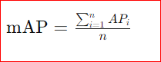

Where:

* n is the total number of classes.
* AP i is the Average Precision for class i.

mAP is commonly used as a benchmark metric for comparing the performance of different object detection models and algorithms. It provides a holistic view of a model's performance, considering both the ability to accurately detect objects within each class and the ability to generalize across multiple classes. Higher mAP scores indicate better overall performance in object detection tasks, reflecting a balance between precision and recall across diverse categories. In this approach face detection using yolov8 is used and input is given as video along with target image and model is trained by using face dataset this gives a value of 90.1 mAP (Mean Average precision) value. An mAP value of 90.1 indicates that the model performs very well on the task of face detection. A higher mAP value signifies better performance. Achieving an mAP of 90.1 suggests that the model can accurately detect faces in various scenarios with high precision and recall.

**CHAPTER 6**

**RESULTS AND SCREENSHOTS**

In this approach face detection using yolov8 is used and input is given as video along with target image and model is trained by using face dataset this gives a value of 90.1 mAp (Mean Average precision) value and it is used as Train Set: 87% (2871 images), Valid Set: 8% (267 images), Test Set: 4% (145 images) and it is also preprocessed with auto-orient is applied along with resized to make stretch to 640x640. For face verification we used the deep face to match faces from face detection output with target input image and output frames are collected and merged into video using Moviepy module and frames processing is done using Apache spark. Output will be video consisting of target image. Incorporating Big data technology like Apache Spark for parallel processing of frames. Input image and video is processed and the frames of the video will be passed to Apache spark and it will be distributing the frames to processors and will be processing parallelly and finally returning the frames which match with the image.

**Input Image**



Fig6.1: Sample Input Image

**Output Screenshots**

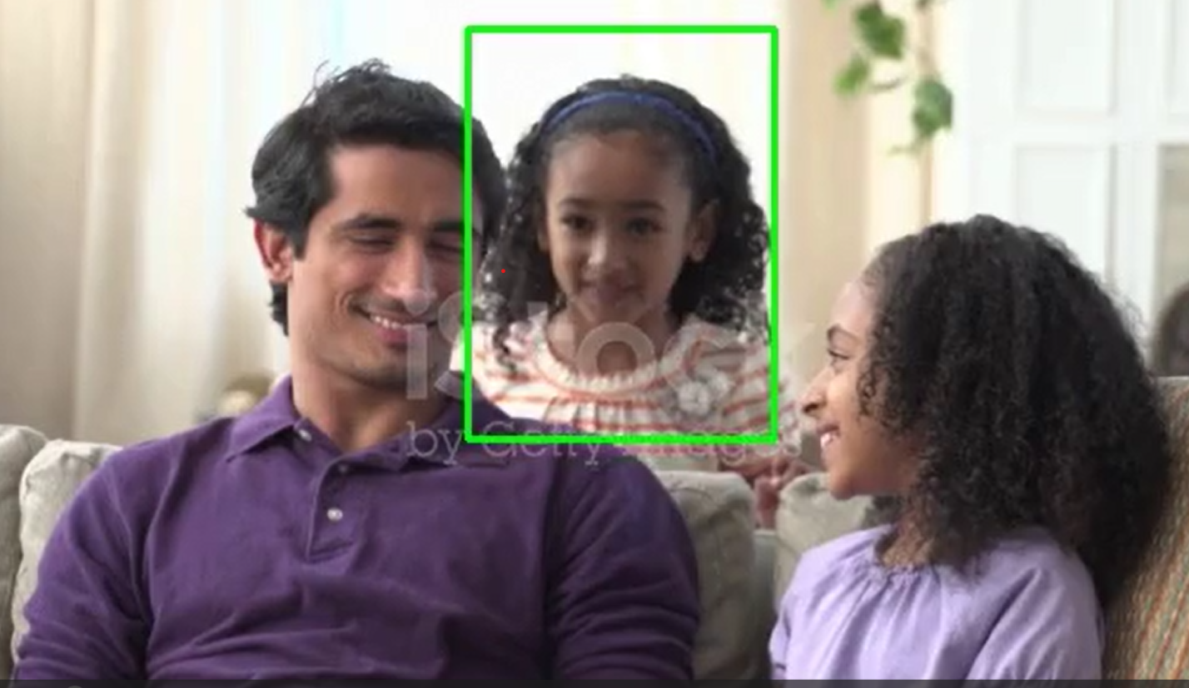

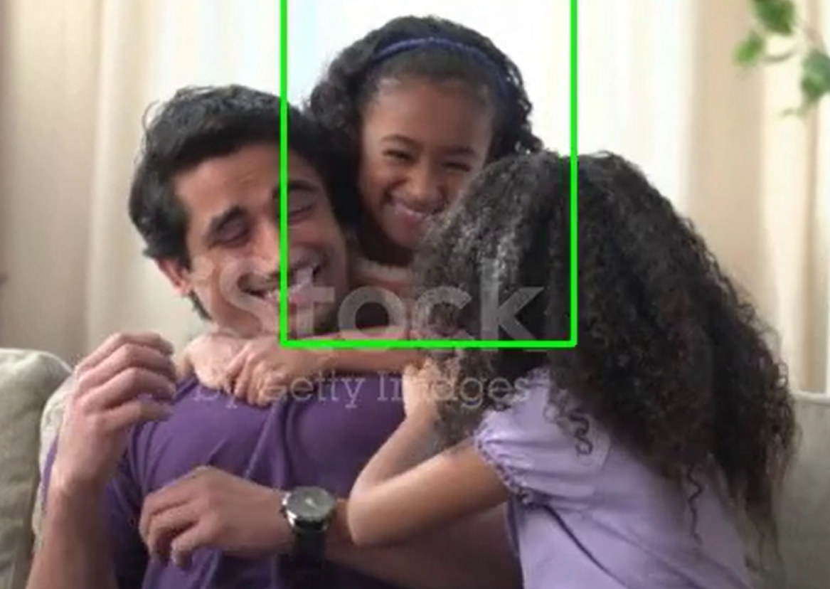

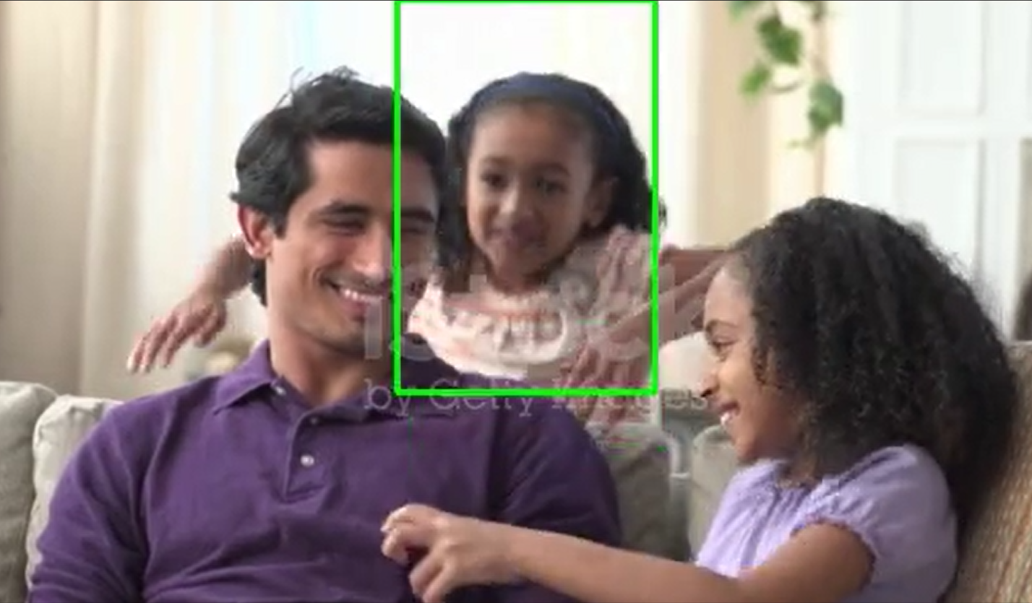

Fig 6.2: Output Screenshot from output video

**CHAPTER 7**

**CONCLUSION AND FUTURE WORK**

**7.1 CONCLUSION**

In conclusion, our project on face detection in videos using big data tools and computer vision techniques highlights the transformative impact of leveraging advanced technologies to address real-world challenges. Computer vision, as a subfield of Artificial Intelligence, plays a crucial role in enabling machines to interpret and understand visual data, with applications ranging from security and surveillance to healthcare and entertainment. Throughout our investigation, we have emphasized the pivotal role of cutting-edge methodologies such as YOLOv8 for efficient face detection and DeepFace for robust face verification, showcasing the potential of these techniques in enhancing accuracy and scalability. Furthermore, our assessment and comparison of recent literature reviews utilizing OpenCV for human face detection underscore the versatility and accessibility of this widely-used library in addressing fundamental image processing tasks. By combining big data tools with state-of-the-art computer vision techniques, our project demonstrates the power of interdisciplinary collaboration in advancing the capabilities of intelligent systems and driving innovation in diverse domains. Looking ahead, the integration of emerging technologies and methodologies holds promise for further advancements in the field of computer vision, paving the way for more sophisticated and impactful applications in the future.

**7.2 FUTURE WORK**

In this approach we used to detect faces from video and to recognize the target image with detected faces in these there may be chance that it may take twins as same and detect while matching the images. In our approach, we employed face detection techniques to identify faces within video streams, followed by facial identification to match detected faces with target images. However, a challenge we encountered was the potential failure to recognize target images due to occlusions or partial obstructions of the faces. To address this limitation, future work will involve implementing image matching algorithms capable of handling occlusions, such as matching images with corresponding masks or dealing with partial facial features. Additionally, to enhance the efficiency of our system by leveraging more processors. By distributing computational tasks across multiple processors, we aim to achieve faster execution times, thereby improving the overall performance and scalability of our face detection and recognition system. This optimization strategy will be instrumental in meeting the demands of real-time applications and large-scale video processing tasks.

**REFERENCES**

[1] Peng, B., & Gopalakrishnan, A. K. (2019). A Face Detection Framework Based on Deep Cascaded Full Convolutional Neural Networks. 2019 IEEE 4th International Conference on Computer and Communication Systems (ICCCS).

[2] Hao, Z., Feng, Q., & Kaidong, L. (2018). An Optimized Face Detection Based on Adaboost Algorithm. 2018 International Conference on Information Systems and Computer Aided Education (ICISCAE).

[3] Wati, D. A. R., & Abadianto, D. (2017). Design of face detection and recognition system for smart home security application. 2017 2nd International Conferences on Information Technology, Information Systems and Electrical Engineering (ICITISEE).

[4] Hsu, H.-W., Wu, T.-Y., Wong, W. H., & Lee, C.-Y. (2018). Correlation-Based Face Detection for Recognizing Faces in Videos. 2018 IEEE International Conference on Acoustics, Speech and Signal Processing (ICASSP).

[5] Rong Xie ,Qingyu Zhang, Enyuan Yang, Qiang Zhu(2019).A method of small Face Detection Based on CNN.2019 4th international Conference on Computational Intelligence and Applications(ICCIA).

[6] Shivalila Hangaragi, Tripty Singh, NeelimaN(2023), Face Detection and Recognition Using Face Mesh and Deep Neural Network. International Conference on Machine Learning and Deep Neural Network.

[7] Shahina Anwarul,Susheela Dahiya(2020). A Comprehensive Review on Face Recognition Methods and Factors Affecting Facial Recognition Accuracy.

[8] Pang, L., Ming, Y., & Chao, L. (2018). F-DR Net:Face detection and recognition in One Net. 2018 14th IEEE International Conference on Signal Processing (ICSP).

[9] Hao Yang and Xiaofeng Han .Face Recognization Attendence System Based on Real time Video Processing (2020).

[10] HtetAung ,Alexander V.Bobkov,Nyan LinTun. Face detection in real time video using Yolo algorithm based on Vgg16 ConvolutionalNeural Network. 2021 International Conference on Industrial Engineering, Applications and Manufacturing (ICIEAM).

[11] Caifeng Shan(2010) Face Recognition and Retrieval in Video.

[12] Davis, M., Popa, S., & Surlea, C. (2010). Real-Time Face Recognition from Surveillance Video. In Intelligent Video Event Analysis and Understanding (1st ed., pp. 155-194). (Studies in Computational Intelligence; Vol. 332). Springer

[13] Ma, M., & Wang, J. (2018). Multi-View Face Detection and Landmark Localization Based on MTCNN. 2018 Chinese Automation Congress (CAC).

[14] Cuimei, L., Zhiliang, Q., Nan, J., & Jianhua, W. (2017). Human face detection algorithm via Haar cascade classifier combined with three additional classifiers. 2017 13th IEEE International Conference on Electronic Measurement & Instruments (ICEMI).

[15] Payal Bose1, Samir K Bandhyopadhyay1 and Vishal Goyal(2020) Human Different Head Poses and Facial Expression Analysis using Principal Component Analysis. 2020 Xeno Journal of Biomedical Sciences.

**APPENDIX**

**Journal Published Certificates**











**Face Detection In A Video Using Big Data Tools And Computer Vision Techniques**

1RamaDevi Gunnam, 2Suneetha Neerumalla, 3Venkata Lakshmi Gayathri Pabbisetty, 4Koteswara Rao Nadikoti, 5Kahar Moula Shaik

1Assistant Professor, 2Student, 3Student, 4Student, 5Student 1Computer Science and Engineering,

1Vasireddy Venkatadri Institute Of Technology, Guntur, India

*Abstract:* Face detection, a process of identifying faces within video content, has traditionally faced limitations in precision. Leveraging big data techniques can enhance speed and efficiency. Employing Apache Spark, capable of running among several nodes simultaneously, facilitates the conversion of individual video frames into an analyzable format. Utilizing the YOLO Face Detection model, rooted in deep learning, enables the detection of faces within each frame. Deep Face will then be utilized to pinpoint the target face and extract all instances across multiple frames for monitoring purposes.

***Index Terms* - Apache Spark, Big Data, Computer Vision, Deep Face, Face Detection, YOLOv8*.***

1. **INTRODUCTION**

The application of face detection in video, leveraging big data tools and computer vision techniques, is a fascinating intersection of intensive handling of data and advanced image analysis. Face detection, a crucial task in computer vision, involves the identification and localization of human faces in still or moving images or video frames. This process plays a vital role in various applications, such as security monitoring, emotion analysis, and facial recognition.

To achieve face detection in videos, algorithms analyses the visual elements of an image or video. Given the considerable volume of data involved in video streams, using big data solutions becomes imperative. Apache Spark, a notable example, proves invaluable due to is scalability, fault tolerance, and distributed processing capabilities.

Furthermore, the efficiency of face detection algorithms is critical in real-world scenarios. They must handle dynamic changes in lighting conditions, varying facial expressions, and diverse backgrounds. Robust algorithms contribute to the accuracy and reliability of applications relying on face detection.

OpenCV, an abbreviation for the Computer Vision OpenSource Library, stands as an open-source software library for computer vision and machine learning tasks. It was initially developed by Intel in 1999 and has since become one of the most widely used libraries for real-time computer vision applications. Here's a breakdown of its key features and capabilities. OpenCV provides a vast array of tools and algorithms for image processing tasks such as filtering, edge detection, morphological operations, and color space manipulation. As face detection applications continue to expand, the integration of real-time processing becomes crucial. Real-time face detection is essential in scenarios such as surveillance, where quick and accurate identification is paramount. This necessitates not only efficient algorithms but also the utilization of parallel processing and optimized hardware for rapid decision-making. Moreover, privacy concerns have become increasingly relevant in the deployment of face detection systems. Striking a balance between the benefits of facial analysis and respecting individual privacy is a critical consideration. Ethical use and responsible handling of facial data are integral aspects that require attention as these technologies advance.

1. **LITERATURE REVIEW**
   1. Face detection in real-world scenarios poses challenges due to variations in expressions, lighting, and occlusions. Deep learning techniques have shown remarkable success in addressing these challenges by leveraging complex strategies. The proposed deep cascaded multi-task framework exploits correlations between tasks, enhancing performance in face detection and landmark localization. Further improvements and applications of the proposed method are envisaged, leveraging the insights gained from experimentation and analysis. [2] This paper provides an extensive overview of face detection methods, categorizing them into feature-based and image-based approaches, with a focus on the burgeoning role of neural networks (NNs). It highlights the historical evolution of face detection algorithms and their recent advancements propelled by computational resources. The comparative evaluation among different algorithms elucidates their strengths and limitations, shedding light on their applicability in diverse scenarios. Notably, NN models emerge as high-performing algorithms in face detection, leveraging hardware developments to tackle challenges like occlusion and complex backgrounds. The survey extends beyond face detection, exploring the extensive utilization of these algorithms in fault diagnosis, EEG data analysis, and various pattern recognition tasks. The research underscores the imperative of advancing face detection technology to mitigate false positives and unlock its full potential in critical domains.

[3] The study presents a novel approach to physical security using facial recognition technology, integrating Haar Cascade for face detection and LBPH for face recognition. The proposed security system prototype utilizes a microcomputer, Raspberry Pi 4, as the central processing unit to analyze camera feed and control access to the secured area. Overall, the proposed security system offers a promising solution for industries seeking enhanced access control and surveillance capabilities, leveraging facial recognition technology for improved security protocols and incident response mechanisms. [4] The proposed correlation-based approach utilizes response maps from CNN models to improve face detection in video sequences, focusing on aligning face features more accurately in the embedding space. Leveraging automatic neuron selection and response map generation techniques, the framework aims to identify optimal face locations for more consistent and interpretable results. Overall, the proposed correlation-based approach offers a novel and effective solution for enhancing face recognition performance in video sequences, with potential applications in various domains requiring robust and accurate facial recognition capabilities.

[5] Face recognition technology, with its capability to capture and match facial features, has witnessed significant advancements, driven by the robustness of deep learning models and its widespread application across various sectors. The proposed AB-FR model integrates an attention based convolutional neural network (CNN) to enhance feature extraction from facial images, thereby improving recognition performance and robustness. By incorporating bidirectional long short-term memory (BiLSTM), the model captures temporal and geometric features across different images of the same individual, addressing the limitations of traditional deep learning-based methods in considering timing characteristics. The utilization of cross-entropy loss function facilitates efficient model optimization and classification, resulting in improved accuracy and training effectiveness. [6] The integration of face mesh technology with deep neural networks represents a promising approach for robust face detection and recognition, offering versatility across varying conditions such as illumination changes and non-frontal poses. Leveraging the Labeled Wild Face (LWF) dataset and real-time image captures, the proposed model demonstrates significant advancements in accurately identifying individuals, with a commendable accuracy rate of 94.23% achieved for face recognition tasks. This research contributes to the evolving landscape of computer vision and deep learning, providing practical solutions for applications ranging from access control in secure areas to database-driven identification systems, thereby addressing key challenges in face detection and recognition.

[7] This paper offers a comprehensive overview of existing face recognition methods and the factors influencing facial recognition accuracy, addressing the heightened demand for biometric security systems in safeguarding against fraud and theft. It delves into the impact of factors such as aging, pose variation, partial occlusion, illumination, and facial expressions on recognition accuracy, while also exploring techniques aimed at mitigating these effects. [8] The F-DR Net represents a pioneering approach in the realm of face multi-task analysis, offering a unified solution for both face detection and recognition within a single network architecture, addressing the challenges posed by these tasks. Extensively evaluated on benchmark datasets such as Labeled Faces in the Wild (LFW) and Face Detection Datasets and Benchmark (FDDB), the F-DR

Net demonstrates superior performance in terms of detection and recognition accuracy while maintaining faster processing speeds compared to existing methods, underscoring its efficacy and practical utility in real- world scenarios. [9] This study presents a new face recognition attendance system leveraging real-time video processing, showcasing its efficacy in enhancing attendance monitoring in educational settings and potentially boosting student engagement and institutional efficiency.

1. This paper presents a thorough review of current research trends in video-based face recognition and retrieval, highlighting the shift from traditional still-image approaches to leveraging the rich and redundant information provided by video data for more accurate and robust recognition in unconstrained environments.
2. This paper presents an experimental surveillance system that addresses the challenges of robust face recognition in real-time applications, emphasizing the utilization of Viola-Jones face detection coupled with shape-based feature extraction to ensure resilience to variations in illumination, scale, pose, and expression, thus enhancing both detection and recognition accuracy. [12] This paper presents a robust approach for face detection in multiple views and landmark localization using Multi-task Cascaded Convolutional Networks (MTCNN), demonstrating high accuracy in both frontal and non-frontal face detection scenarios. The proposed method enhances detection accuracy, particularly for large-angle faces, offering a comprehensive solution for complex environments.



1. **PROPOSED METHODOLOGY**
   1. **Understanding Yolov8 Architecture**

Fig 1:Yolov8 Architecture

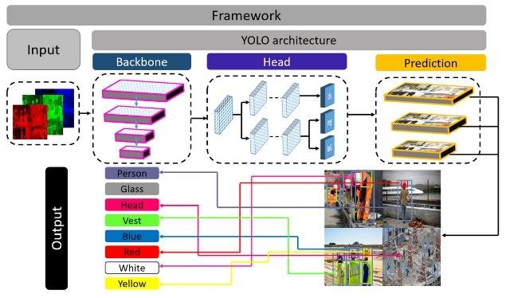

YOLOv8, or You Only Look Once version 8, is an object detection algorithm that belongs to the YOLO (You Only Look Once) family of models. YOLO models are known for their real-time object detection capabilities, meaning they can quickly and accurately identify objects within an image or a video frame.

Backbone Network: YOLOv8 uses a backbone network, often based on CSPDarknet53, which is an extended version of Darknet, a deep neural network designed for object detection. The backbone extracts features from the input image.

Feature Pyramid Network (FPN): YOLOv8 employs a Feature Pyramid Network to capture features at different scales. This helps in detecting objects of varying sizes within an image.

Detection Head: The detection head in YOLOv8 is tasked with predicting both bounding boxes and the probabilities of various classes. It uses a set of convolutional layers to process the feature maps from the backbone and FPN, producing predictions for each grid cell.

Anchor Boxes: YOLOv8 utilizes anchor boxes to improve bounding box prediction accuracy. These anchor boxes are predefined sizes that help the model better adapt to the scale of different objects in the image.

Output Format: The final output of YOLOv8 is a set of bounding boxes, each associated with a specific class and its confidence score. The bounding boxes are predicted for different grid cells and anchor boxes at multiple scales.

Training: YOLOv8 is trained using a combination of labeled images and their corresponding bounding box annotations. The model is optimized using techniques like stochastic gradient descent with backpropagation.

Variants: YOLOv8 has different variants, including YOLOv8-S, YOLOv8-M, YOLOv8-L, and YOLOv8-X, with varying model sizes and computational demands. Users can choose a variant based on their specific requirements regarding speed and accuracy.

Efficiency and Real-time Processing: YOLOv8 is known for its efficiency, making it suitable for real-time object detection applications. It processes the entire image in one forward pass, eliminating the need for complex post-processing steps.

It's important to note that YOLOv8 builds upon the success of its predecessors and incorporates improvements to enhance detection accuracy and speed. The architecture's flexibility and balance between accuracy and speed make it a popular choice for various computer vision tasks.

* 1. **Understanding Deep Face**

Fig 2: Deep Face Architecture

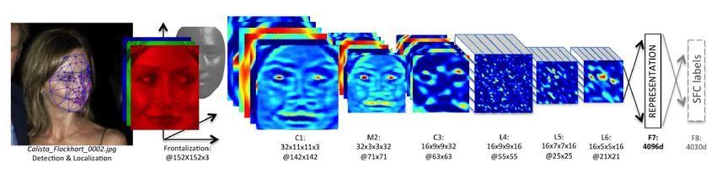

"Deep Face" refers to a deep learning-based face recognition system developed by Facebook's AI Research (FAIR) lab. It gained significant attention when it was introduced in 2014 due to its high accuracy in identifying faces across large datasets. Here's an overview:

Architecture: Deep Face utilizes a deep convolutional neural network (CNN) architecture, which is trained on a massive dataset of labeled face images. The network consists of multiple layers that learn hierarchical representations of facial features, enabling it to recognize faces with high accuracy.

Face Verification: Deep Face is primarily designed for face verification tasks, which involve determining whether two face images belong to the same person or not. It accomplishes this by encoding facial images into a compact representation (embedding) in a high-dimensional space, where the similarity between two embeddings can be measured using techniques like cosine similarity or Euclidean distance.

Training Data: Deep Face was trained on a large-scale dataset called the "Social Face Classification" dataset, which contains millions of labeled face images belonging to thousands of individuals. This extensive training dataset helped Deep Face learn robust representations of facial features, enabling it to generalize well to unseen faces.

Performance: Deep Face achieved state-of-the-art performance on various face recognition benchmarks, surpassing previous methods in terms of accuracy and scalability. In particular, it demonstrated high accuracy even in challenging conditions such as variations in pose, lighting, and facial expression.

Applications: Deep Face has various applications in areas such as biometric authentication, surveillance, social media, and photo tagging. It can be used to automatically tag friends in photos on social media platforms, verify users' identities for secure access control, and assist in law enforcement efforts for identifying individuals in surveillance footage.

Privacy and Ethical Considerations: The deployment of facial recognition systems like Deep Face raises concerns about privacy, surveillance, and potential misuse of personal data. Critics argue that such technologies can infringe on individuals' privacy rights and exacerbate surveillance issues if not regulated properly. Therefore, ethical considerations and regulatory frameworks are crucial in ensuring responsible creation and use of facial recognition technology.

Overall, Deep Face represents a significant advancement in the field of face recognition, demonstrating the power of deep learning techniques for accurately identifying and verifying individuals in images. However, it also underscores the importance of addressing privacy and ethical concerns associated with the widespread adoption of facial recognition technology.

* 1. **Understanding Apache Spark**

 Fig 3: Architecture Of Apache Spark

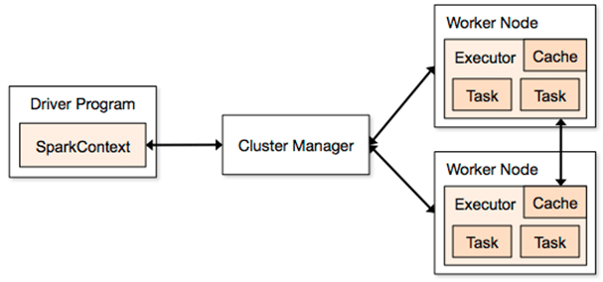

Fast and versatile, Apache Spark is a cluster computing platform made. for distributed data processing. It offers a programming interface with implicit fault tolerance and data parallelism for entire clusters. Spark was created in Scala and is compatible with many programming languages, such as java, Python and R, so a broad spectrum of developers can use it.

There are lot of features in spark. When compared to other conventional data processing technologies, Spark is renowned for its extraordinary speed. By using in-memory processing, it lessens the requirement for a lot of disk input/output. Faster processing speeds are achieved by optimizing job execution through the usage of the Directed Acyclic Graph (DAG) execution.

A high-level API in Java, Scala, Python and R is provided by Spark, which streamlines the development process. Additionally, it offers interactive shell functionality so that code snippets can be examined and tested before being integrated into more complex workflows

There is high adaptability in Apache Spark. Resilient distributed datasets and lineage information are two ways that spark provides fault tolerance. Spark can recompute an RDD using lineage information in the event that a partition is lost, guaranteeing data integrity and dependability.

1. **IMPLEMENTATION**
   1. **Dataset Description:**
      1. **Dataset Preparation:**

The dataset consists of images containing faces, with each face annotated with bounding boxes. This dataset name is FaceDetection18.

Fig 4: Dataset Images

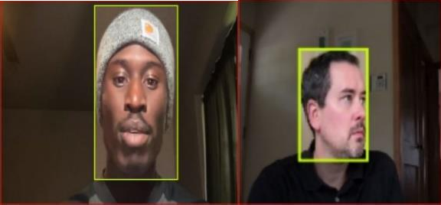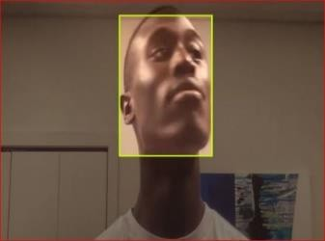

Dataset split:

Train Set: 87% (2871 images)

Valid Set: 8% (267 images)

Test Set: 4% (145 images)

Each image is annotated with bounding boxes indicating the location of faces.

* + 1. **Data Preprocessing:**

Dataset is preprocessed as

Auto-Orient: Applied

Resize: Stretch to 640*649

* + 1. **Data Augmentation:**

Table 1

|  |  |
| --- | --- |
| Parameters | Value |
| 90deg Rotate | Clockwise, Counter-Clockwise,Upside  Down |
| Flip | Horizontal, Vertical |
| Crop | 0% Minimum Zoom, 25% Maximum  Zoom |
| Gray Scale | Apply to 5% of images |
| Hue | Between -20° and +20° |
| Saturation | Between -10% and +10% |
| Brightness | Between -10% and +10% |
| Exposure | Between -10% and +10% |
| Blur | Up to 1px |
| Cutout | 5boxes with 2% size each |

* 1. **Model Training in Face Detection:**

The YOLOv8 model architecture is used for face detection tasks.

* + 1. **The training process involves:**

Initializing the YOLOv8 model with pre-trained weights (yolov8s.pt). Setting up data loaders to load the training dataset. Training the model on the training dataset for multiple epochs.

* + 1. **Model Validation:**

After training, the trained model is validated on a separate validation set to evaluate its performance. The validation process includes: Initializing the validation module with the trained model and validation dataset. Computing various metrics using confusion matrix for object detection tasks. Evaluating the model's performance on the validation dataset and recording the evaluation results.

* + 1. **Prediction on Unseen Data:**

Once the model is trained and validated, it can be used to make predictions on unseen data, such as images or videos containing faces.

* 1. **Face Verification using Deep Faces**

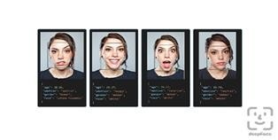

Load the pretrained Deep Face model and Here input is given as detected faces file and target image to get instances of input image in video. Here the algorithm extract the features from detected faces and match features against known identities.

Fig 5: Deep Face Example

Verify function under the deep face interface is used for face recognition. Modern face recognition

pipelines consist of 4 stages: detect, align, represent and verify. Deep Face handles all these common stages in the background.

Each call of verification builds a face recognition model from scratch and this is a costly operation. If you are going to verify multiple faces sequentially, then you should pass an array of faces to verification function to speed the operation up. In this way, complex face recognition models will be built once.

Sample code:

from deepface import DeepFace result=DeepFace.verify("img1.jpg","img2.jpg") print("Is verified: ", result["verified"])

Combining the processed frames into Video:

Here, in these combining frames we take the matched faces of frames from deep face module and combine them using Moviepy module.

Applying Big data:

Applied big data for parallel processing of frames using Apache spark. Input image and video is processed and the frames of the video will be passed to Apache spark and it will be distributing the frames to processors and will be processing parallelly and finally returning the frames which match with the image.

1. **RESULTS AND DISCUSSIONS**

In this approach face detection using yolov8 is used and input is given as video along with target image and model is trained by using face dataset this gives a value of 90.1 mAp (**Mean Average precision**) value and it is used as Train Set: 87% (2871 images), Valid Set: 8% (267 images), Test Set: 4% (145 images) and it is also preprocessed with auto-orient is applied along with resized to make stretch to 640x640. For face verification we used the deep face to match faces from face detection output with target input image and output frames are collected and merged into video using Moviepy module and frames processing is done using Apache spark. Output will be video consisting of target image. Incorporating Big data technology like Apache Spark for parallel processing of frames. Input image and video is processed and the frames of the video will be passed to Apache spark and it will be distributing the frames to processors and will be processing parallelly and finally returning the frames which match with the image.

Fig 6: Output Image1

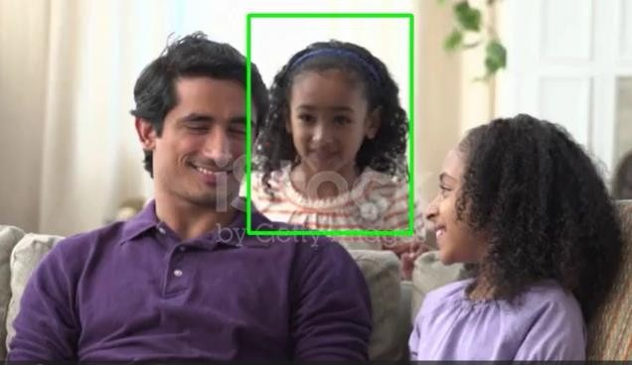

Fig 7: Output Image2

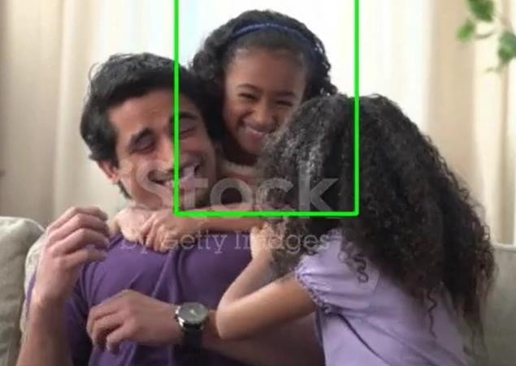

1. **CONCLUSIONS**

Computer Vision is the subfield of Artificial Intelligence, where computers are trained to process the image and extract the important features from the images or videos. Applications of computer vision are object detection, face recognition, medical diagnosis, etc. In this paper we emphasize the important role of yolov8 for face detection and deep face for face verification. Finally, we assessment and compared recent literature reviews that use Opencv to detect the human face.

1. **LIMITATIONS AND FUTURE SCOPE**

In this approach we used to detect faces from video and to recognize the target image with detected faces in these there may be chance that it may not recognize images with some occlusions.Future work includes the matching the image with masks and also as include the working with more processors for faster execution.

1. **ACKNOWLEDGMENTS**

The authors would like to thank the CSE Department and extend our sincere appreciation for the assistance and guidance provided throughout the completion of this paper. Our gratitude goes to our project guide and project coordinator for their invaluable support and advice throughout the project.

**REFERENCES**

1. Yuxuan Liao, Zhenyu Tang, Jiehong Lei, Jiajia Chen, &Zhong Tang. (2022). Video Face Detection Technology and Its Application in Health Information Management System
2. Supriya Priya R Asaithambi, Sitalakshmi Venkataraman, & Ramanathan Venkataraman. (2021). Proposed Big data architecture for facial recognition using machine learning
3. Peng, B., & Gopalakrishnan, A. K. (2019). A Face Detection Framework Based on Deep Cascaded Full Convolutional Neural Networks. 2019 IEEE 4th International Conference on Computer and Communication Systems (ICCCS).
4. Hao, Z., Feng, Q., & Kaidong, L. (2018). An Optimized Face Detection Based on Adaboost Algorithm. 2018 International Conference on Information Systems and Computer Aided Education (ICISCAE).
5. Wati, D. A. R., & Abadianto, D. (2017). Design of face detection and recognition system for smart home security application. 2017 2nd International Conferences on Information Technology, Information Systems and Electrical Engineering (ICITISEE).
6. Hsu, H.-W., Wu, T.-Y., Wong, W. H., & Lee, C.-Y. (2018). Correlation-Based Face Detection for Recognizing Faces in Videos. 2018 IEEE International Conference on Acoustics, Speech and Signal Processing (ICASSP).
7. Rong Xie ,Qingyu Zhang, Enyuan Yang, Qiang Zhu(2019).A method of small Face Detection Based on CNN.2019 4th international Conference on Computational Intelligence and Applications(ICCIA)
8. Shivalila Hangaragi, Tripty Singh, NeelimaN(2023), Face Detection and Recognition Using Face Mesh and Deep Neural Network. International Conference on Machine Learning and Deep Neural Network.
9. Shahina Anwarul,Susheela Dahiya(2020). A Comprehensive Review on Face Recognition Methods and Factors Affecting Facial Recognition Accuracy.
10. Pang, L., Ming, Y., & Chao, L. (2018). F-DR Net:Face detection and recognition in One Net. 2018 14th IEEE International Conference on Signal Processing (ICSP).
11. Hao Yang and Xiaofeng Han .Face Recognization Attendence System Based on Real time Video Processing (2020).
12. HtetAung ,Alexander V.Bobkov,Nyan LinTun. Face detection in real time video using Yolo algorithm based on Vgg16 ConvolutionalNeural Network. 2021 International Conference on Industrial Engineering, Applications and Manufacturing (ICIEAM).
13. Caifeng Shan(2010) Face Recognition and Retrieval in Video
14. Davis, M., Popa, S., & Surlea, C. (2010). Real-Time Face Recognition from Surveillance Video. In Intelligent Video Event Analysis and Understanding (1st ed., pp. 155-194). (Studies in Computational Intelligence; Vol. 332). Springer
15. Ma, M., & Wang, J. (2018). Multi-View Face Detection and Landmark Localization Based on MTCNN. 2018 Chinese Automation Congress (CAC).
16. Cuimei, L., Zhiliang, Q., Nan, J., & Jianhua, W. (2017). Human face detection algorithm via Haar cascade classifier combined with three additional classifiers. 2017 13th IEEE International Conference on Electronic Measurement & Instruments (ICEMI).
17. Payal Bose1, Samir K Bandhyopadhyay1 and Vishal Goyal(2020) Human Different Head Poses and Facial Expression Analysis using Principal Component Analysis. 2020 Xeno Journal of Biomedical Sciences.